**WD - JAVASCRIPT Essentials & Advanced**

**Q.1 Using console.log() print out the following statement: The quote 'There is no exercise better for the heart than reaching down and lifting people up.' by John Holmes teaches us to help one another. Using console.log() print out the following quote by Mother Teresa:**

**A.1**

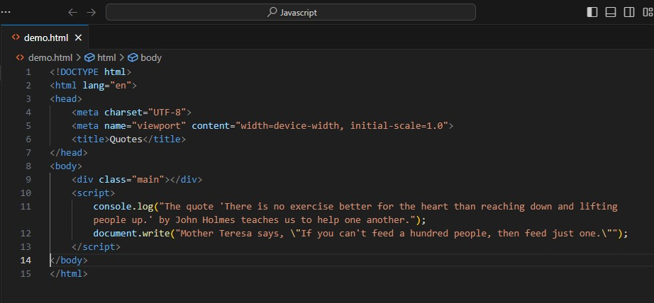

**Output:-**

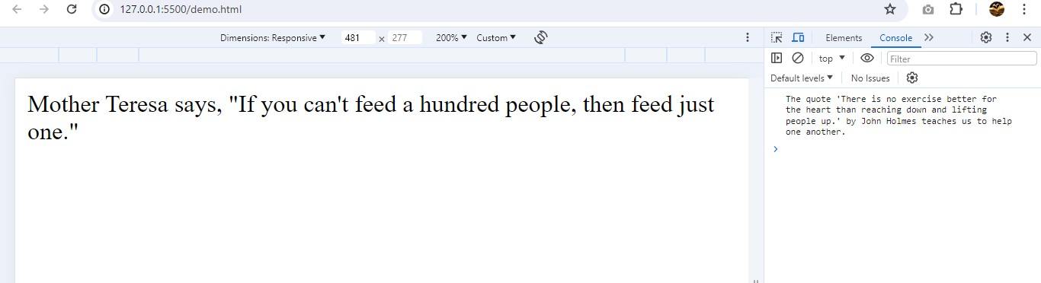

**Q.2 Check if typeof '10' is exactly equal to 10. If not make it exactly equal?**

**A.2** To check if the type of '10' is exactly equal to the type of 10, and to make them exactly equal if they are not, you can follow these steps in JavaScript:

1. Compare the types and values.
2. Convert the string '10' to a number if necessary.
3. Ensure that they are exactly equal in both value and type.

Here is the JavaScript code to achieve this:

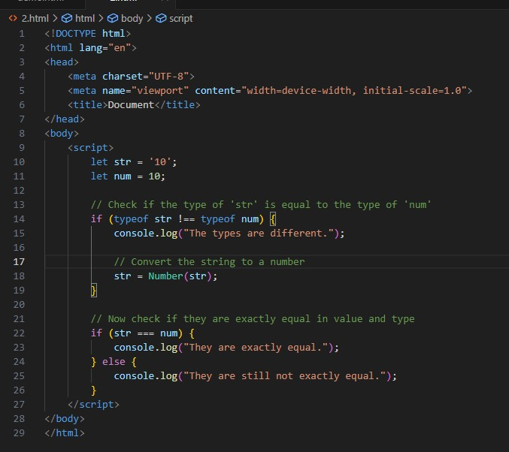

**Output:-** 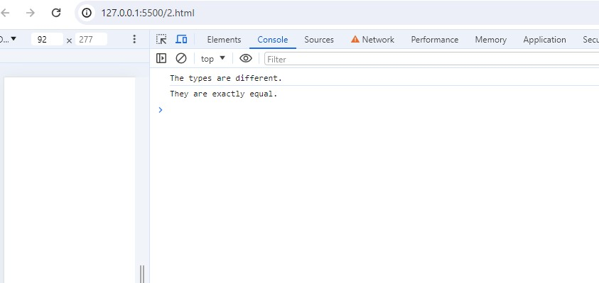

**Q.3 Write a JavaScript Program to find the area of a triangle?**

**A.3** We can use the formula for the area of a triangle:

**Area**

**=12×base×heightArea=21​×base×height**

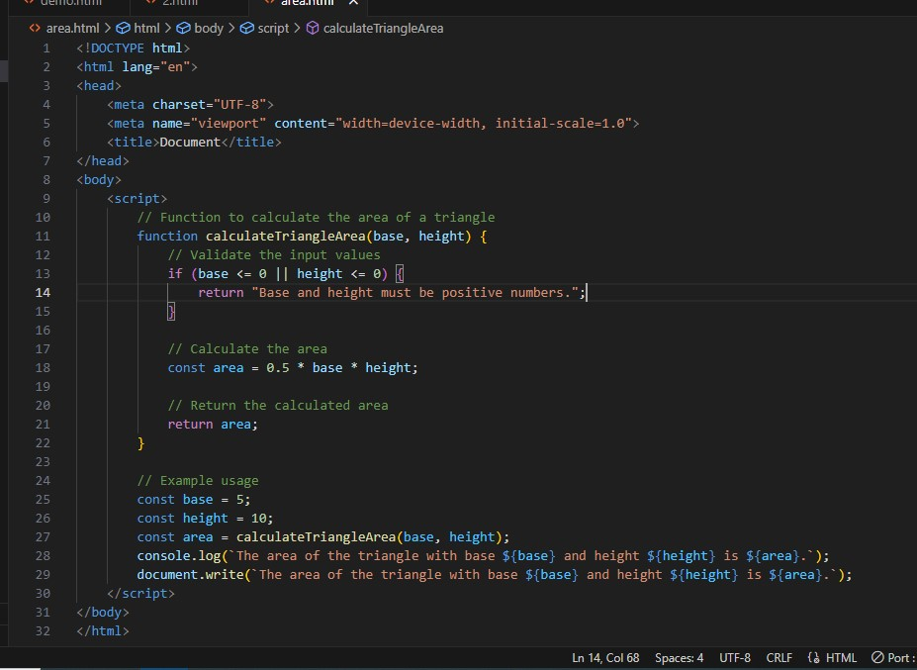

**Output:-** 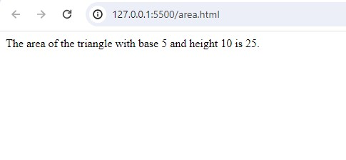

**Q.4 Write a JavaScript program to calculate days left until next Christmas?**

**A.4** Here is a JavaScript program to calculate the number of days left until the next Christmas:

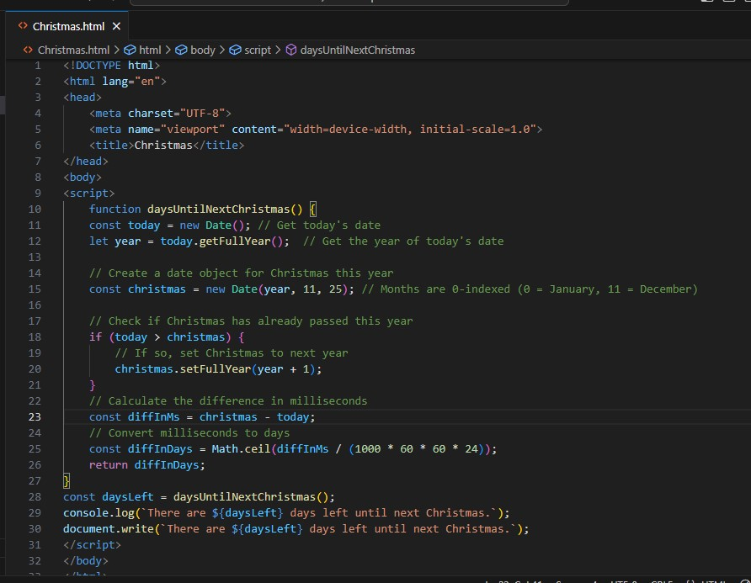

**Output:-** 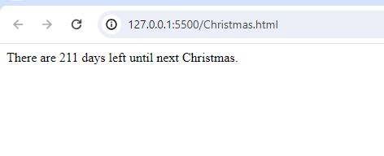

**Q.5 What is Condition Statement?**

**A.5** Conditional statements in programming are used to**control the flow of a program** based on certain conditions. These statements allow the execution of different code blocks depending on whether a specified condition evaluates to true or false, providing a fundamental mechanism for**decision-making**in algorithms. In this article, we will learn about the basics of Conditional Statements along with their different types.

**Q.6 Find circumference of Rectangle formula : C = 4 * a ?**

**A.11 Output:-**

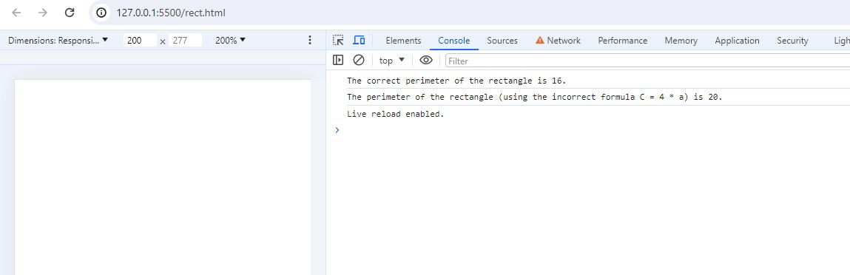

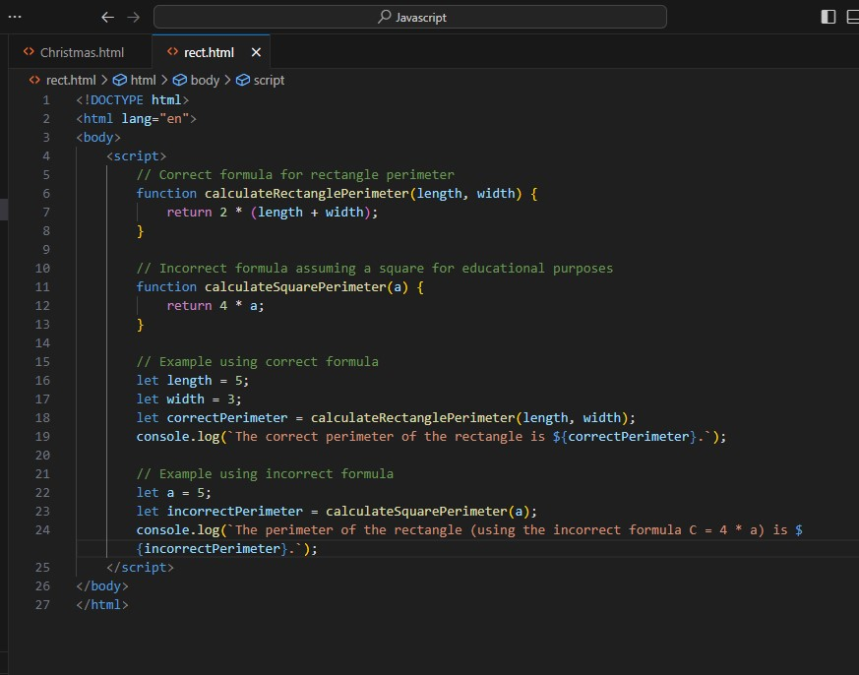

**Q.7 WAP to convert years into days and days into years?**

**A.7 Convert Years to Days :-** To convert years to days, you multiply the number of years by 365 (assuming a non-leap year).

For leap years, you could consider an average of 365.25 days per year to account for the extra day every four years.

**Convert Days to Years :-** To convert days to years, you divide the number of days by 365.

**Output:-**

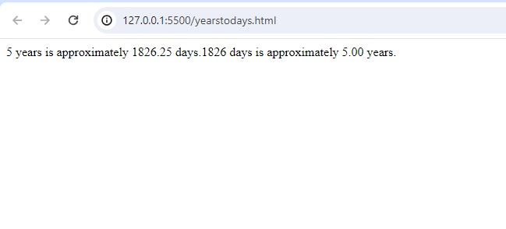

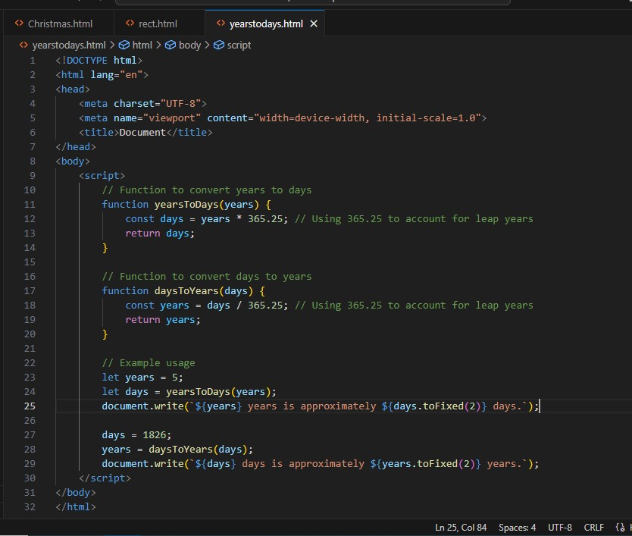

**Q.8 Convert temperature Fahrenheit to Celsius? (Conditional logic Question)**

**A.8** To convert temperature from Fahrenheit to Celsius, we can use the following formula:

𝐶=59×(𝐹−32)*C*=95​×(*F*−32)

Where:

𝐶*C* is the temperature in Celsius,

𝐹*F* is the temperature in Fahrenheit.

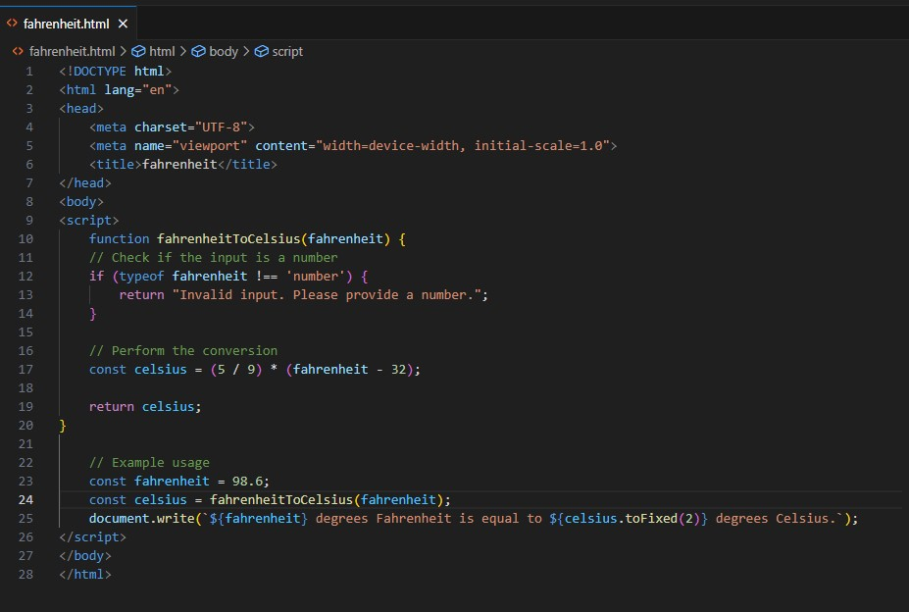

**Output:-**

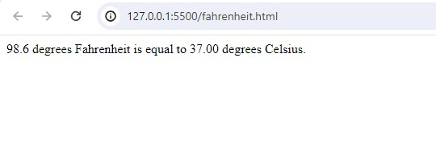

**Q.9 Write a JavaScript exercise to get the extension of a filename.?**

**A.9**

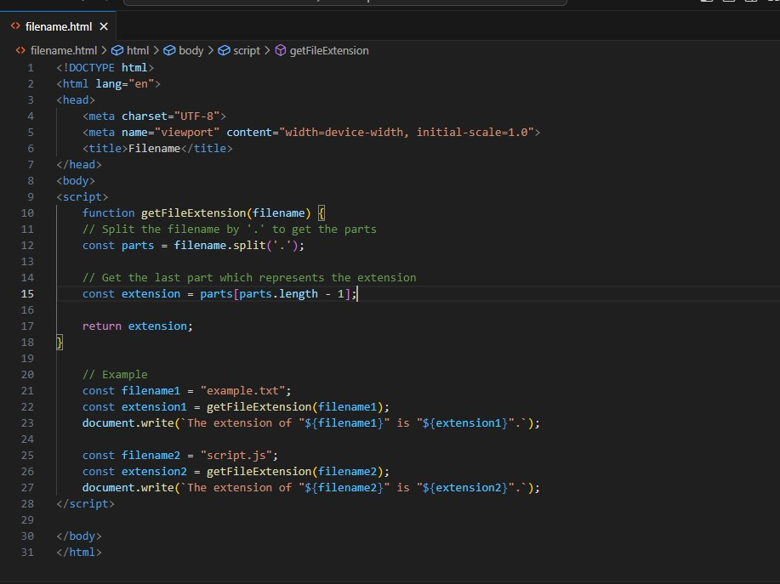

**Output:-**

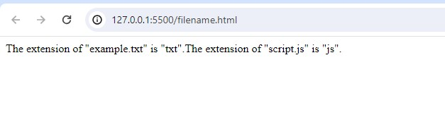

**Q.10 What is the result of the expression (5 > 3 && 2 < 4)?**

**A.10** Let's evaluate the expression (5 > 3 && 2 < 4) step by step:

* 5 > 3: This evaluates to true because 5 is greater than 3.
* 2 < 4: This evaluates to true because 2 is less than 4.

Combining them with the logical AND operator (&&), since both conditions are true, the result is true.

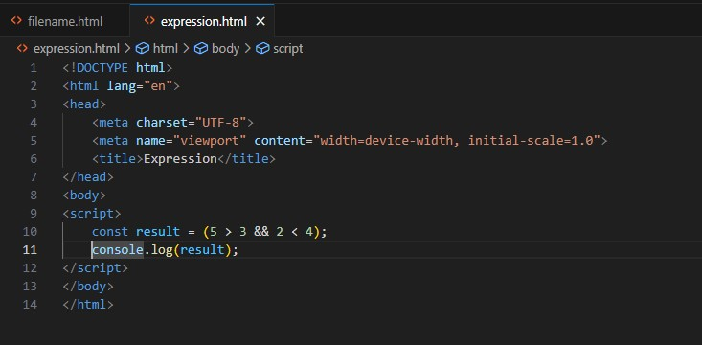

**Output:-**

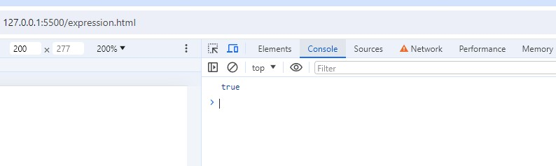

**Q.11 What is the result of the expression (true && 1 && "hello")?**

**A.11** Let's evaluate the expression (true && 1 && "hello") step by step:

true: This evaluates to true because it's a boolean value.

1: This evaluates to true because any non-zero number in JavaScript is considered truthy.

"hello": This evaluates to true because a non-empty string in JavaScript is considered truthy.

Since all operands are truthy, the && operator returns the last truthy value, which is "hello".

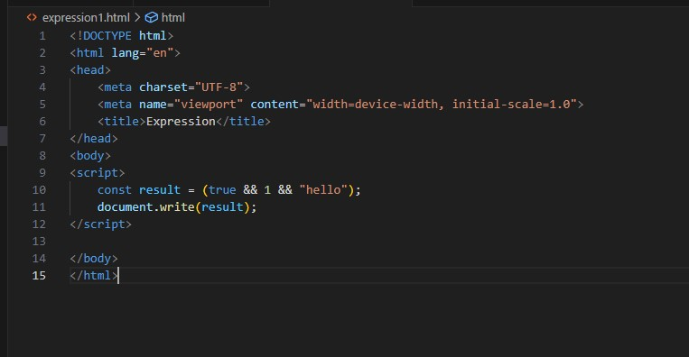

**Output:-**

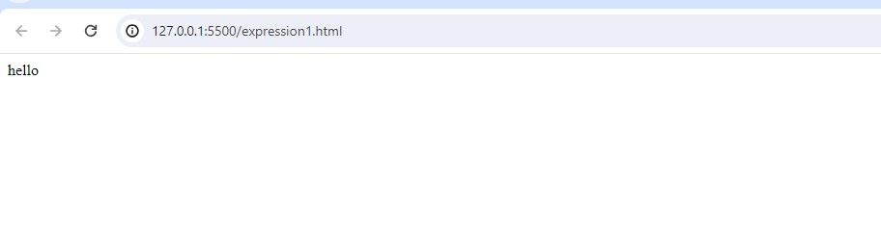

**Q.12 What is the result of the expression true && false || false && true?**

**A.12** let's evaluate the expression step by step:

true && false: This evaluates to false because one of the operands is false.

false && true: This also evaluates to false because one of the operands is false.

Finally, false || false: This evaluates to false because both operands are false.

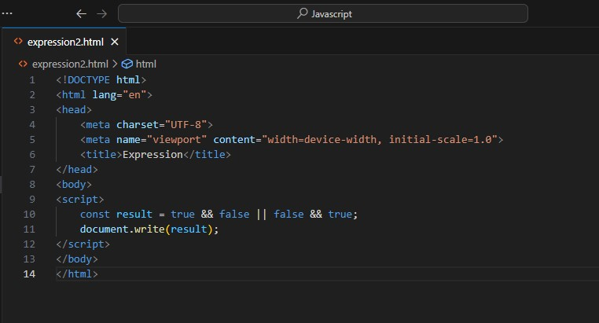

**Output:-**

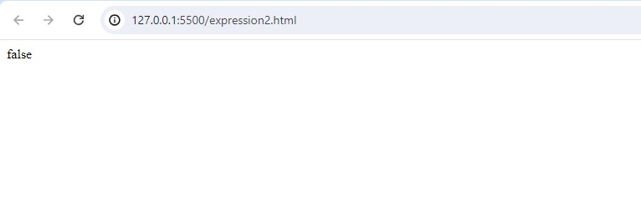**Q.13 Check Number Is Positive or Negative in JavaScript?**

**A.13**

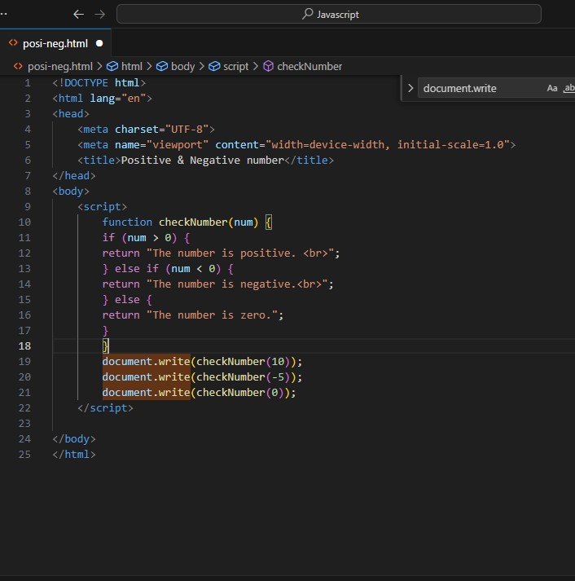

**Output:-**

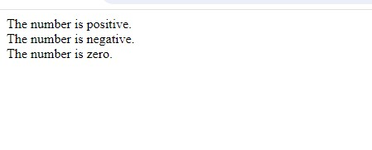

**Q.14 Find the Character Is Vowel or Not ?**

**A.14**

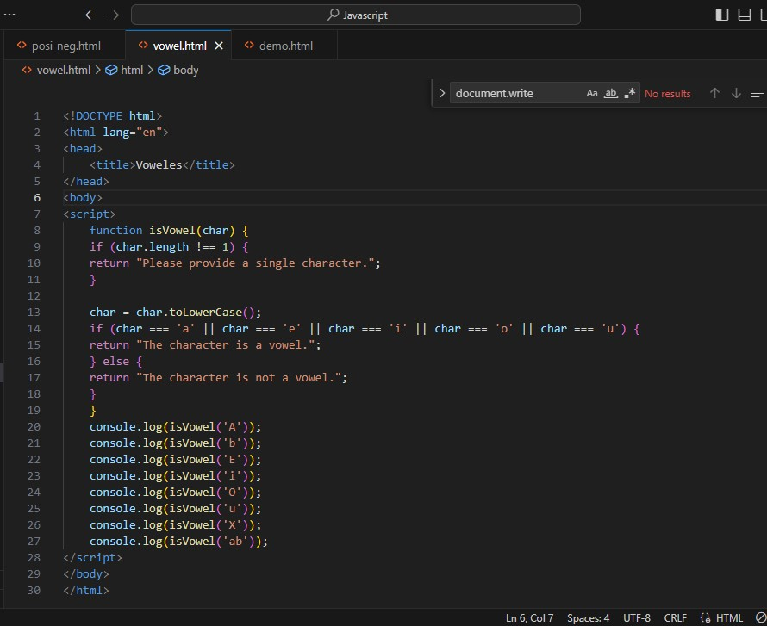**Output:-**

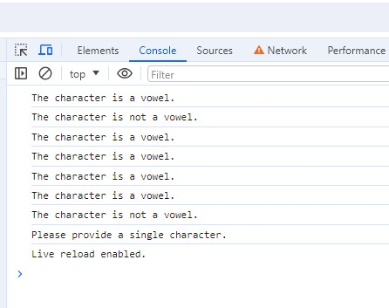

**Q.15 Write to check whether a number is negative, positive or zero?**

**A.15**

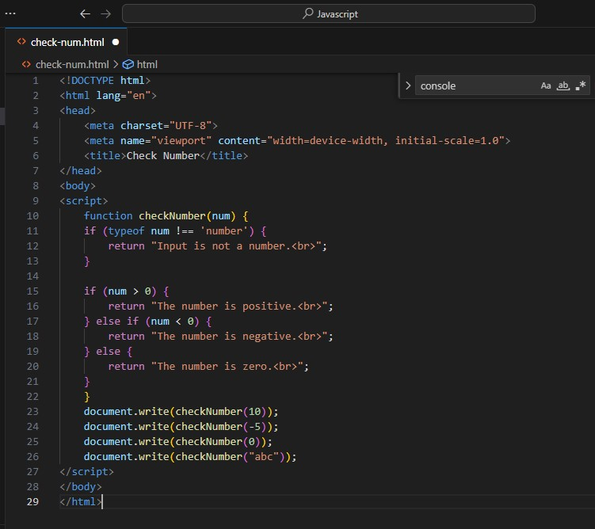

**Output:-**

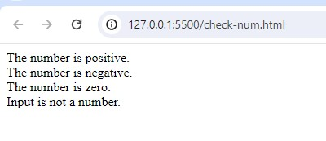

**Q.16 Write to find number is even or odd using ternary operator in JS?**

**A.16** 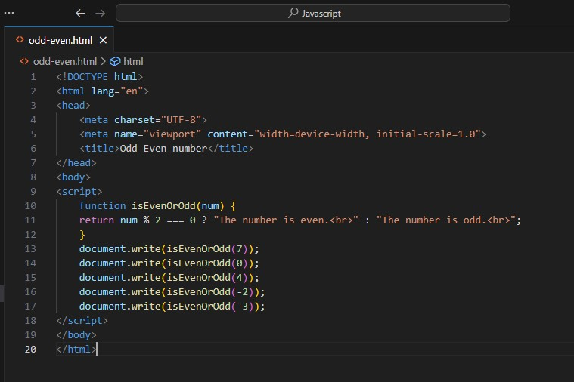

**Output:-**

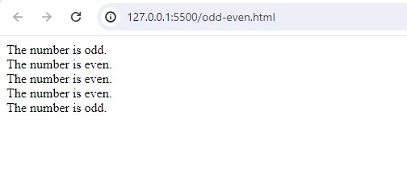

**Q.17 Write find maximum number among 3 numbers using ternary operator in JS?**

**A.17**

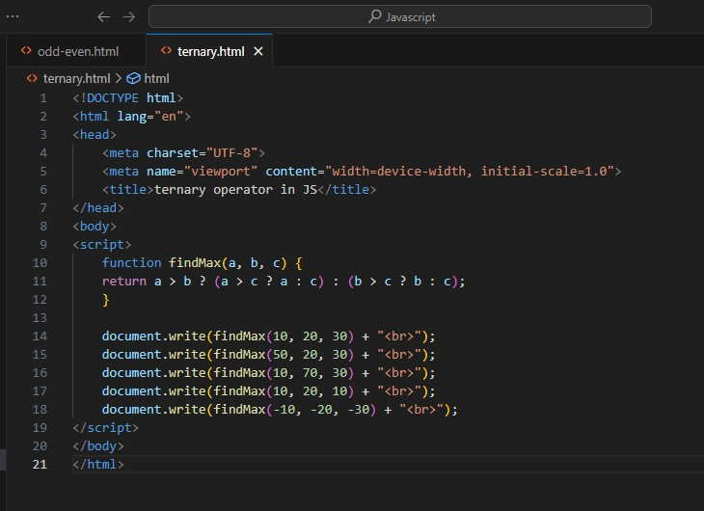

**Output:-**

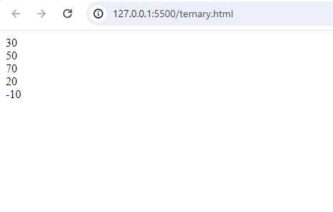

**Q.18 Write to find minimum number among 3 numbers using ternary operator in JS?**

**A.18**

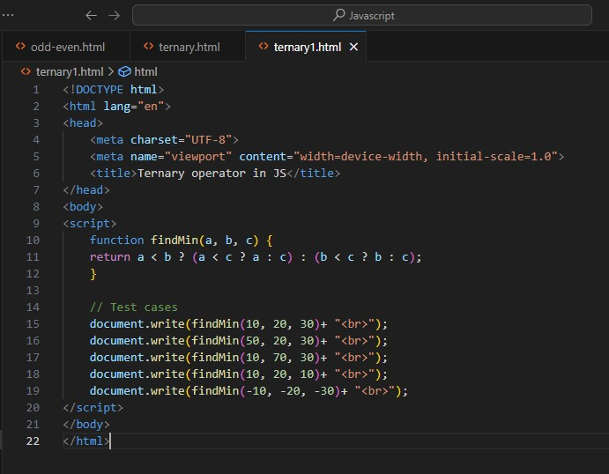

**Output:-**

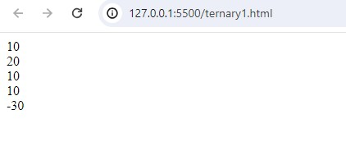

**Q.19 Write to find the largest of three numbers in JS?**

**A.19**

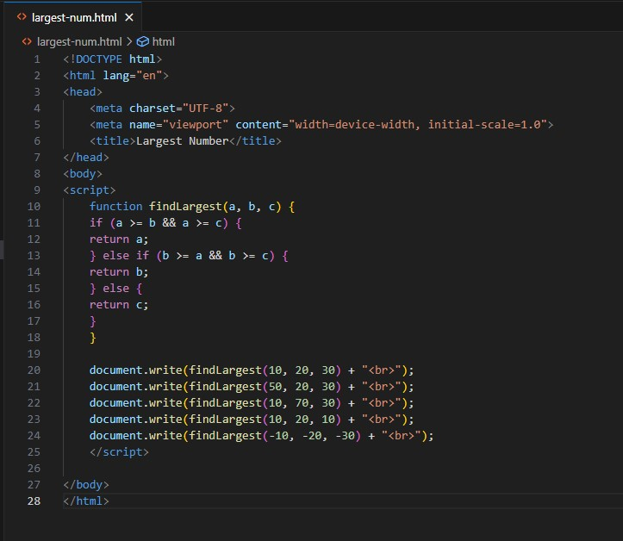

**Output:-**

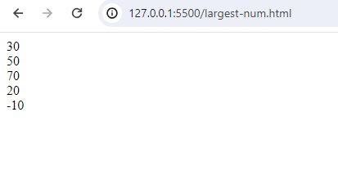

**Q.20 Write to show i. Monday to Sunday using switch case in JS? ii. Vowel or Consonant using switch case in JS?**

**A.20** i. Monday to Sunday using switch case in JS

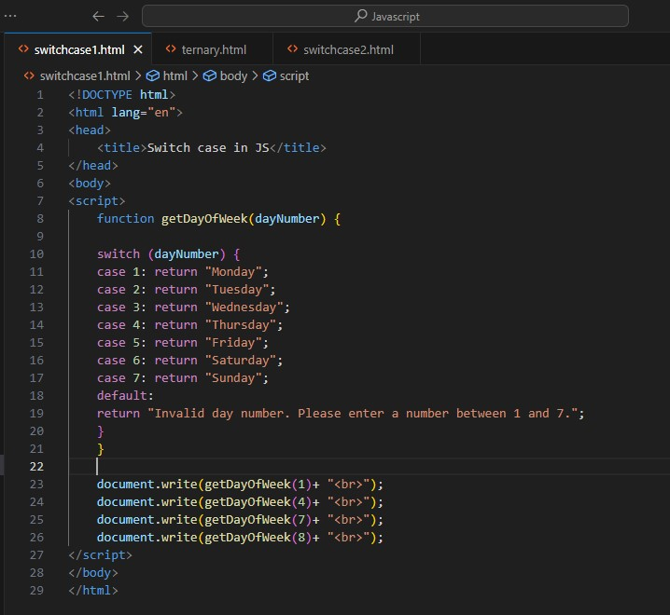

**Output:-**

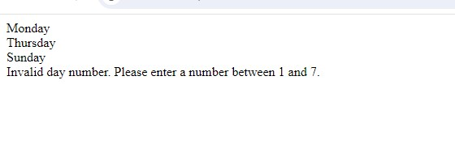

ii. Vowel or Consonant using switch case in JS

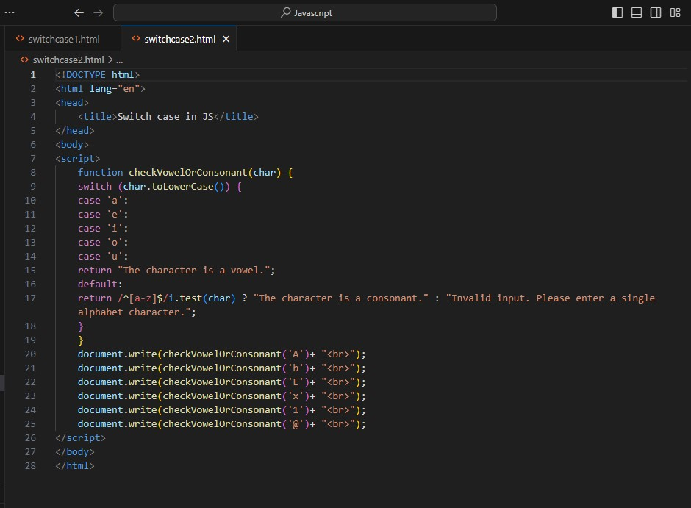

**Output:-**

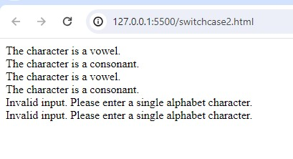

**(Conditional looping logic Question)**

**Q.21 What are the looping structures in JavaScript? Any one Example?**

**A.21** In JavaScript, there are several looping structures you can use to repeat code execution. The main looping structures are:

**for loop**: Executes a block of code a specified number of times.

**while loop**: Executes a block of code as long as a specified condition is true.

**do...while loop**: Similar to a while loop, but the code block is executed at least once before the condition is tested.

**for...in loop**: Iterates over the enumerable properties of an object.

**for...of loop**: Iterates over iterable objects such as arrays, strings, maps, sets, etc.

Here's an example of a simple for loop that iterates from 1 to 5 and prints the current value:

For ( let i = 1; i <= 5; i++ ){

Document.write(i);

}

output:- 1

2

3

4

5

**Q.22 Write a print 972 to 897 using for loop in JS?**

**A.22**

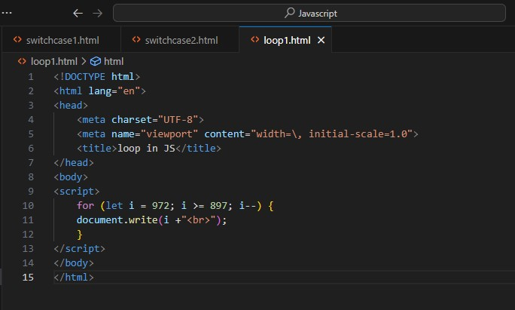

**Output:-**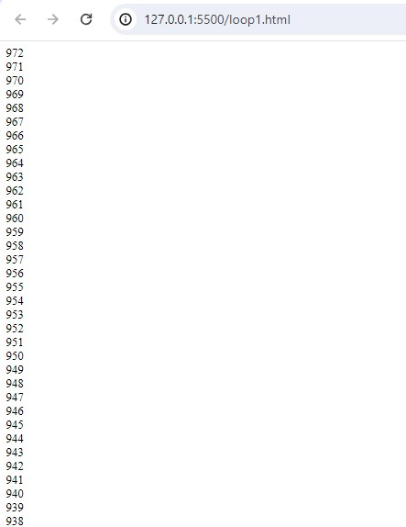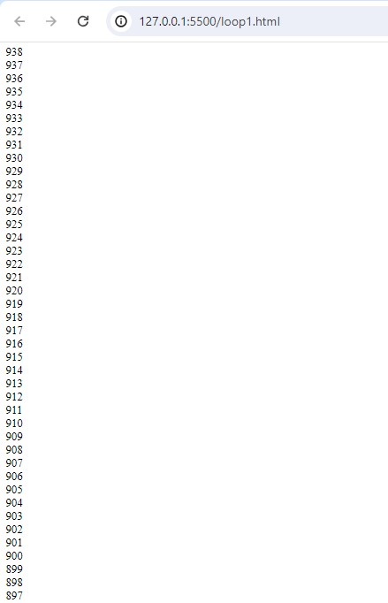

**Q.23 Write to print factorial of given number?**

**A.23**

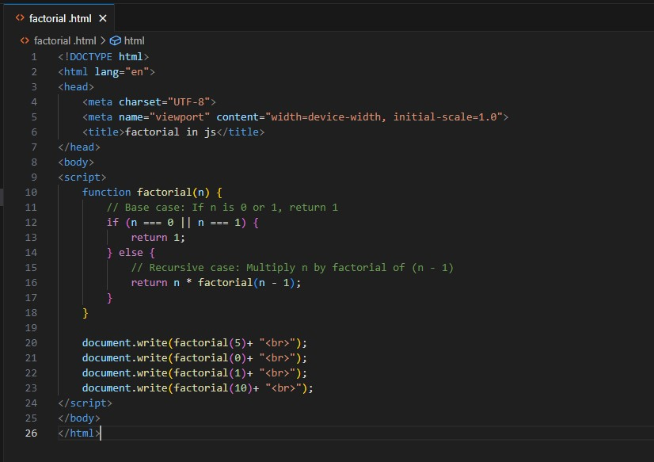

**Output:-**

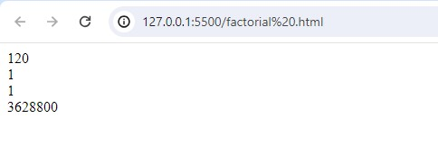

**Q.24 Write to print Fibonacci series up to given numbers?**

**A.24**

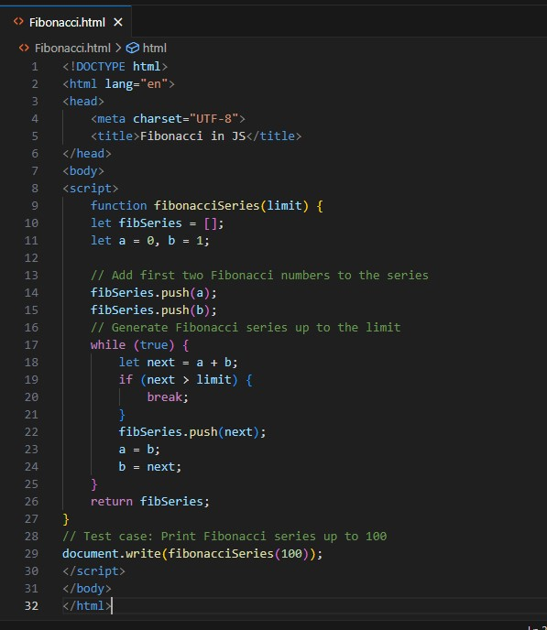

**Output:-**

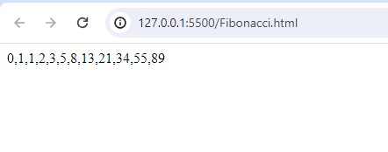

**Q.25 Write to print number in reverse order e.g.: number = 64728 ---> re**

**verse =82746 in JS?**

**A.25**

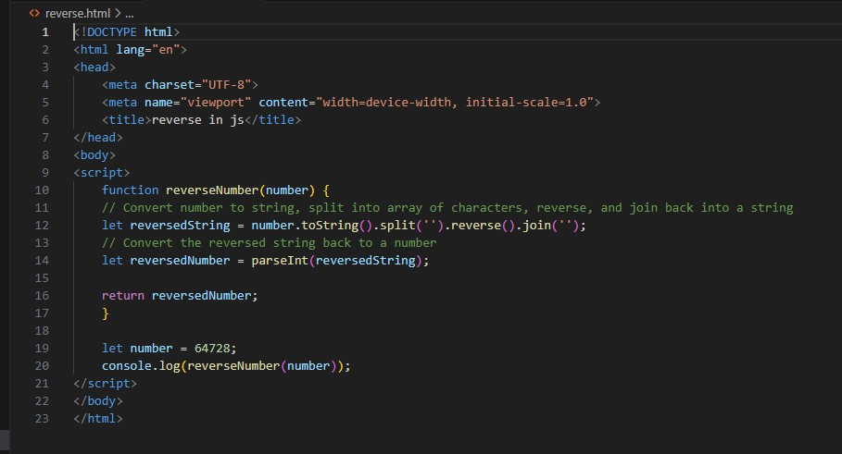

**Output:-**

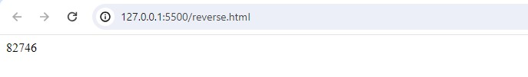

**Q.26 Write a program make a summation of given number (E.g., 1523 Ans: - 11) in JS?**

**A.26**

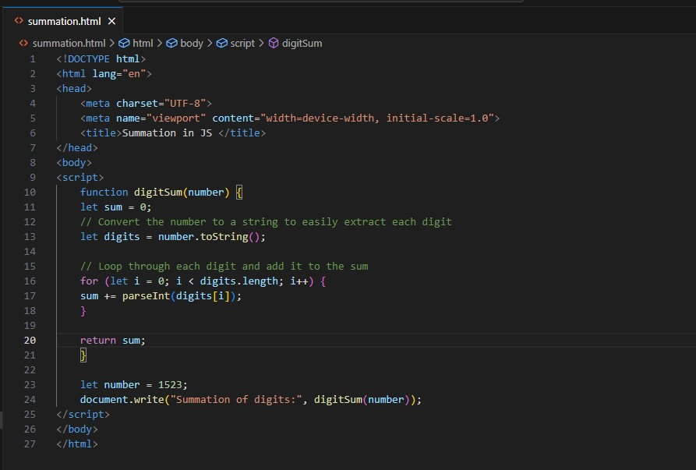

**Output:-**

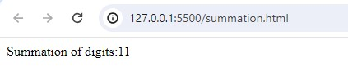

**Q.27 Write a program you have to make a summation of first and last Digit. (E.g., 1234 Ans: - 5) in JS?**

**A.27**

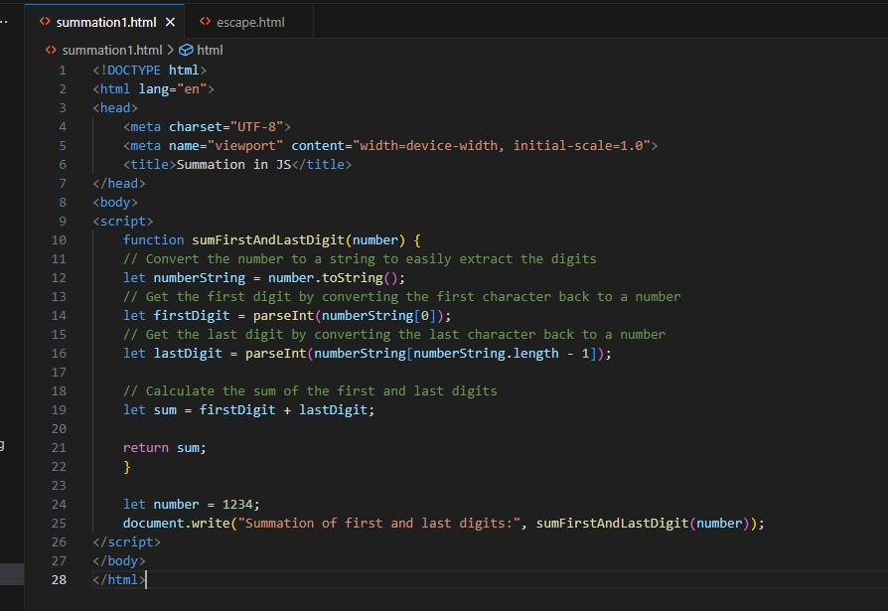

**Output:-**

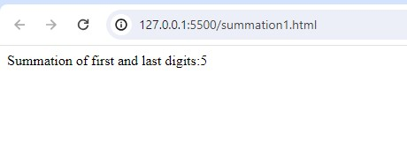

**Q.28 Use console.log() and escape characters to print the following pattern in JS?**

**A.28**

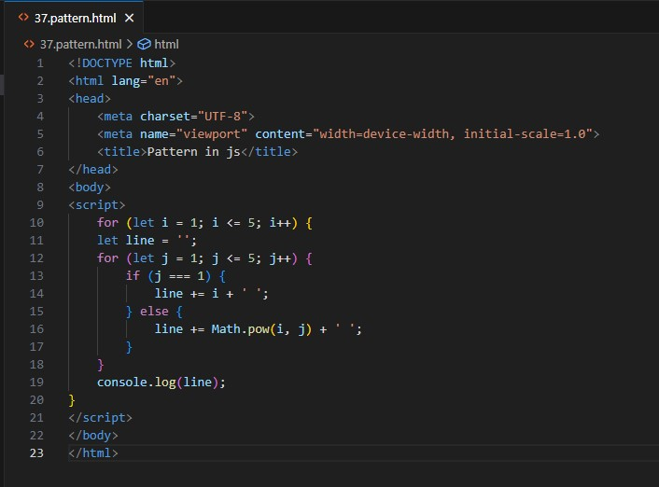

**Output:-**

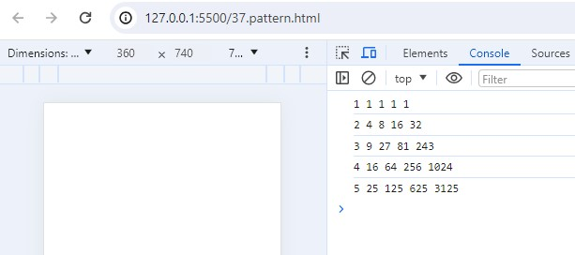

**Q.29 Use pattern in console.log in JS?**

**A.29**

**1) 1**

**1 0**

**1 0 1**

**1 0 1 0**

**1 0 1 0 1**

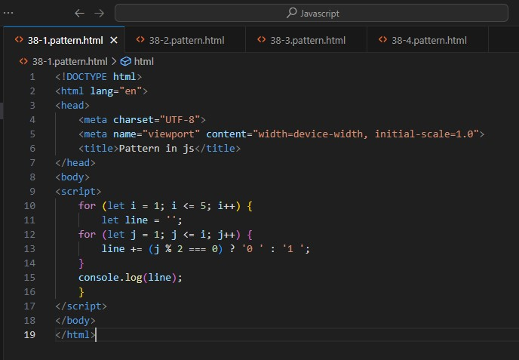

**2) A**

# **B C**

# **D E F**

# **G H I J**

# **K L M N O**

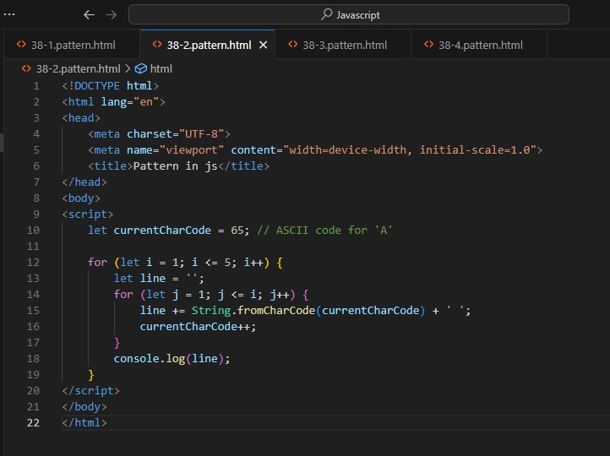

**3) 1**

**2 3**

**4 5 6**

**7 8 9 10**

**11 12 13 14 15**

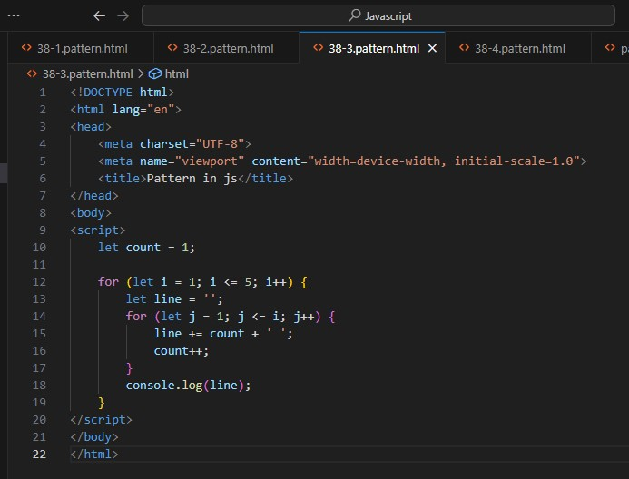

**4)**

**\***

**\* \***

**\* * \***

**\* * * \***

**\* * * * \***

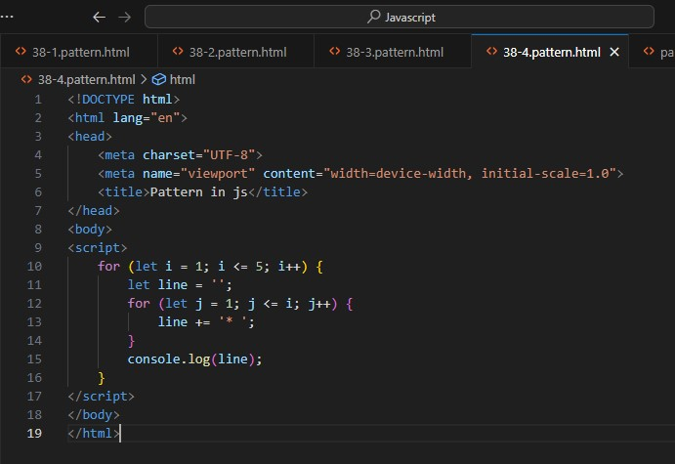

**Q.30 Accept 3 numbers from user using while loop and check each numbers palindrome?**

**A.30**

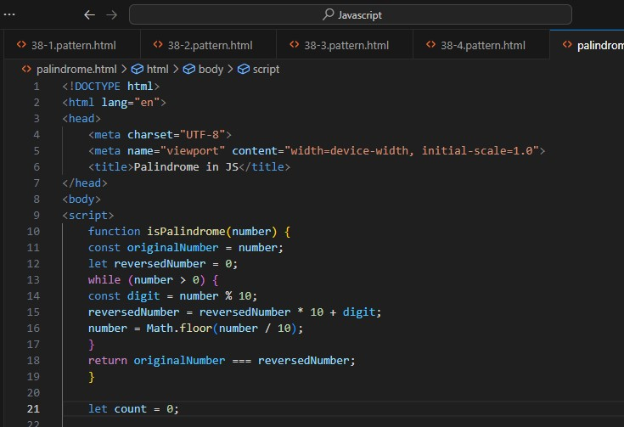

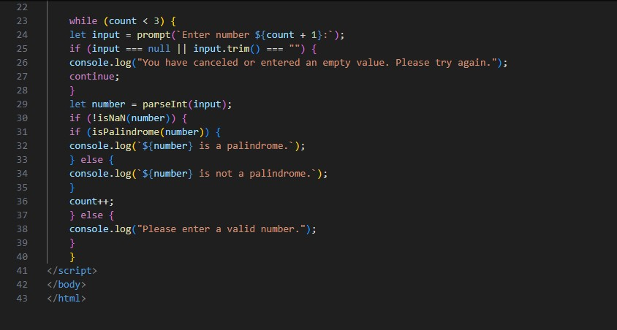

**Output:-**

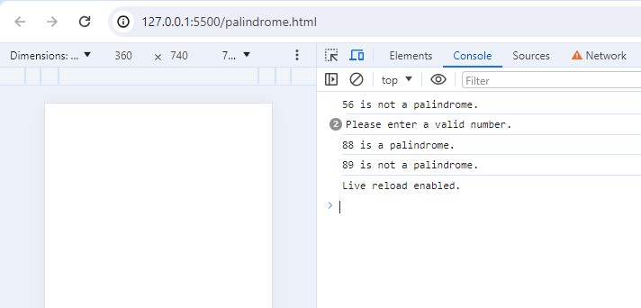

**Q.31 Write a JavaScript Program to display the current day and time in the following format. Sample Output: Today is Friday. Current Time is 12 PM: 12 : 22 2 ?**

**A.31**

**Output:-**

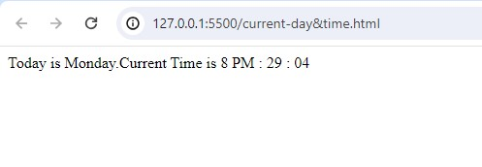

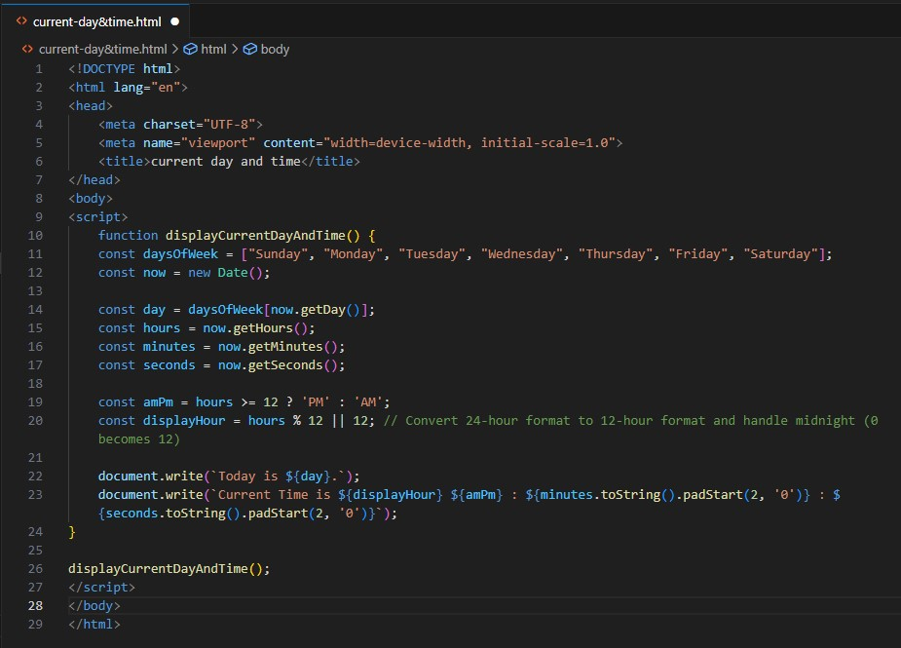

**Q.32 Write a JavaScript program to get the current date?**

**A.32**

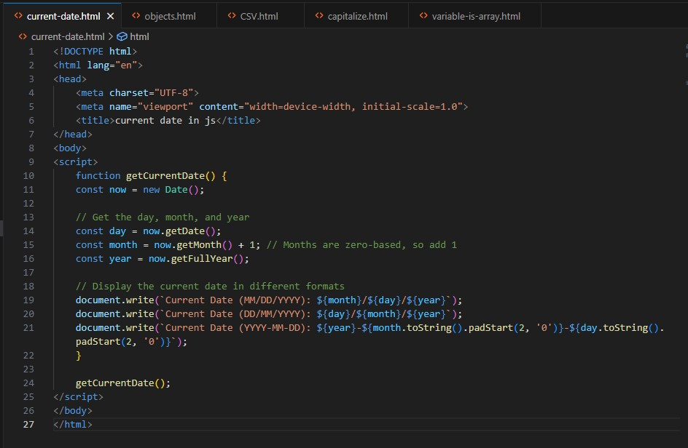

**Output:-**

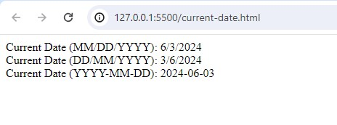

**Q.33 Write a JavaScript program to compare two objects?**

**A.33**

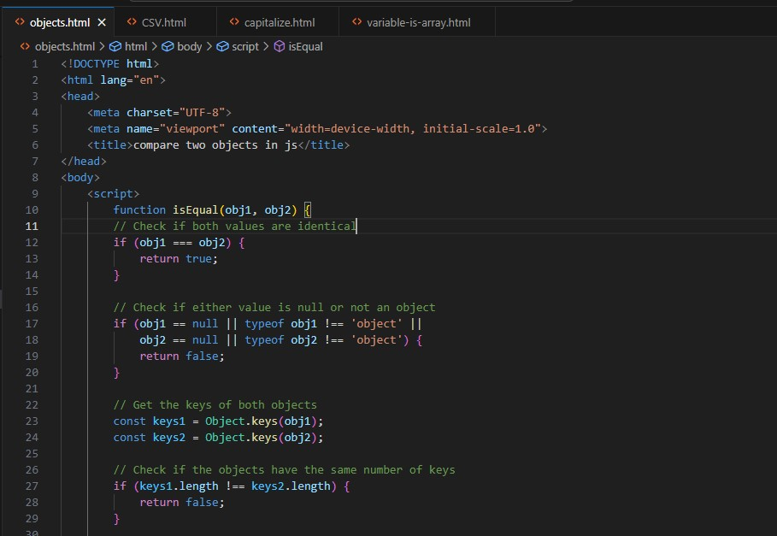

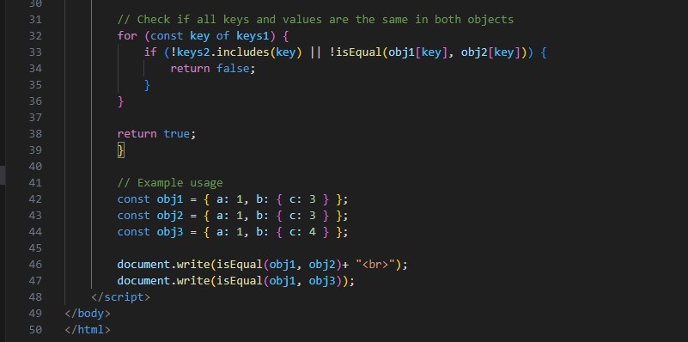

**Output:-**

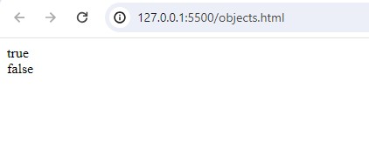

**Q.34 Write a JavaScript program to convert an array of objects into CSV string?**

**A.34**

**Output:-**

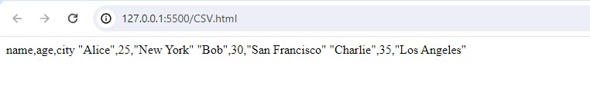

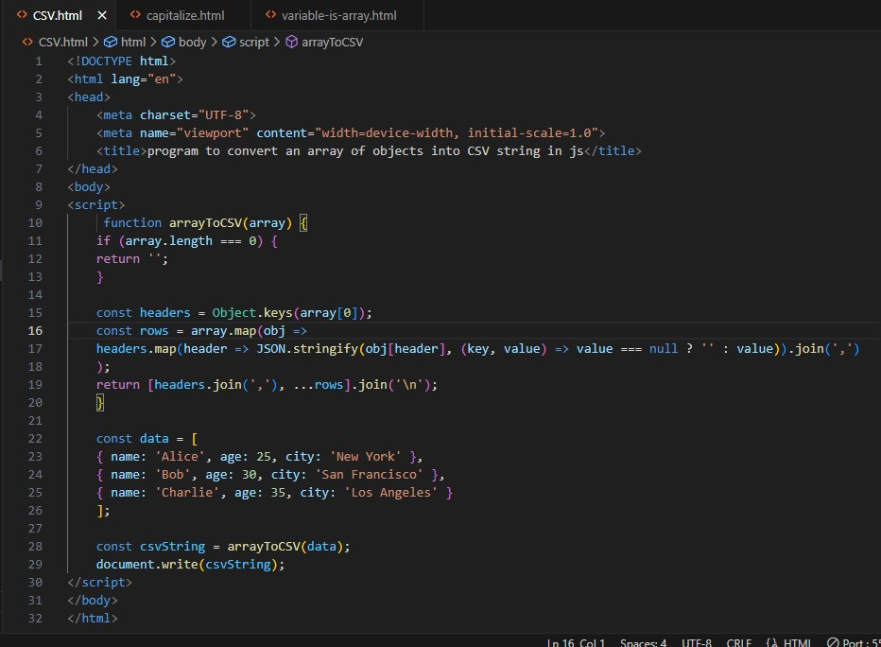

**Q.35 Write a JavaScript program to capitalize first letter of a string?**

**A.35**

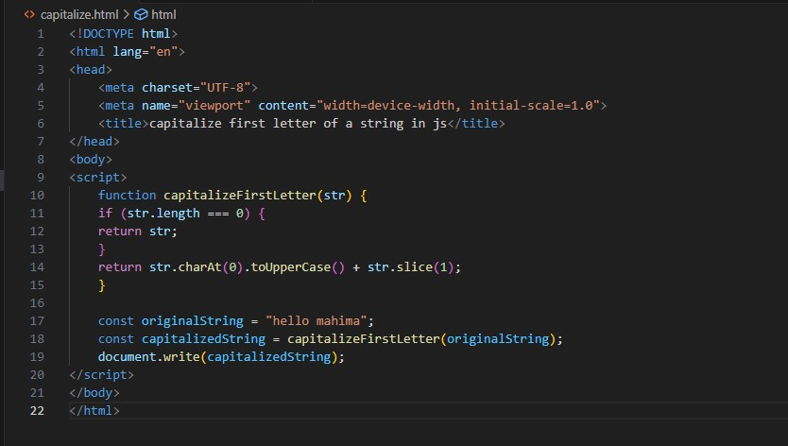

**Output:-**

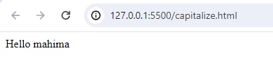

**Q. 36 Write a JavaScript program to determine if a variable is array?**

**A.36**

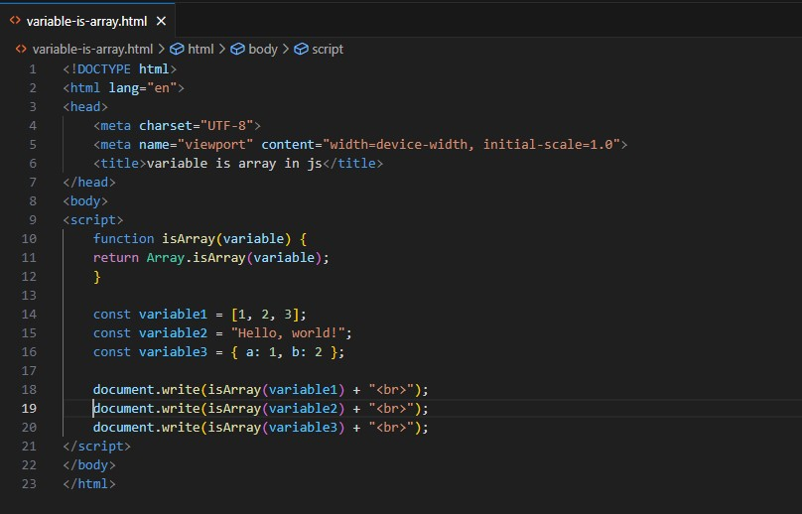

**Output:-**

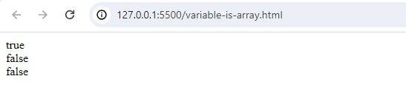

**Q.46 Write a JavaScript program to clone an array?**

**A.46**

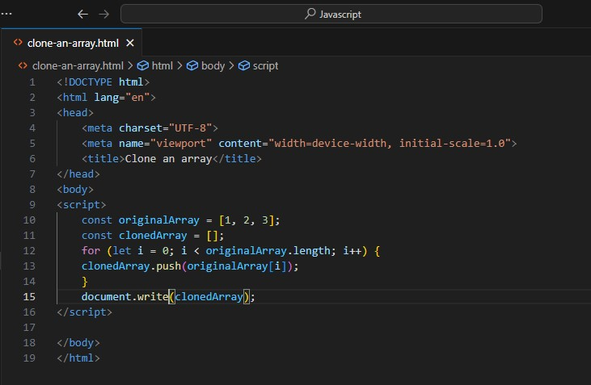

**Output:-**

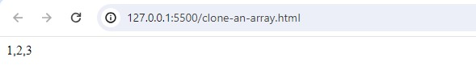

**Q.47 What is the drawback of declaring methods directly in JavaScript objects?**

**A.47** Drawback of declaring methods directly in JavaScript objects

Memory Consumption

Inefficiency

Difficulties with Inheritance

Encapsulation

**Q.48 Print the length of the string on the browser console using console.log()?**

**A.48**

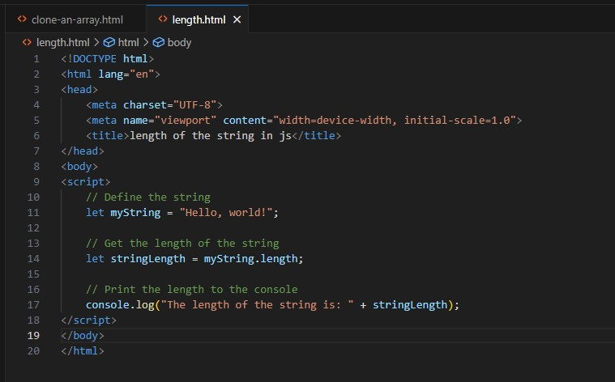

**Output:-**

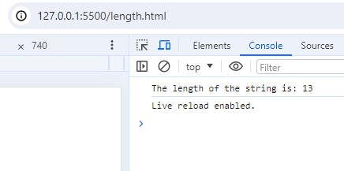

**Q.49 Change all the string characters to capital letters using toUpperCase() method?**

**A.49**

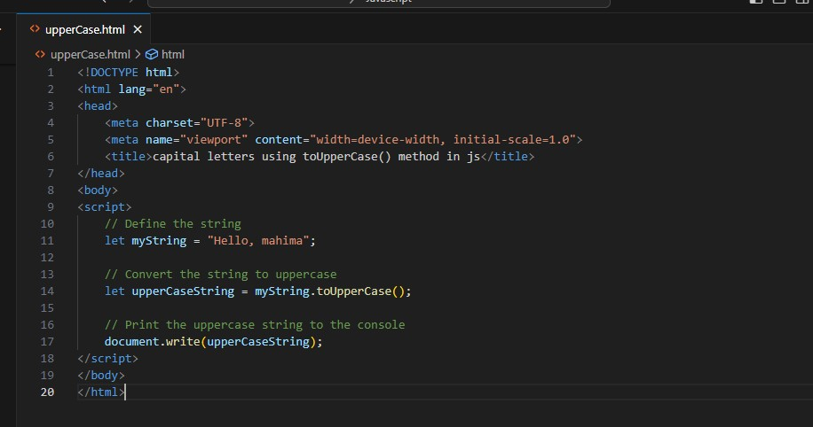

**Output:-**

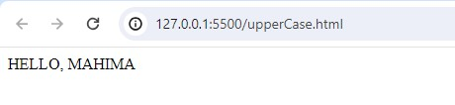

**Q.50 What is the drawback of declaring methods directly in JavaScript objects?**

**A.50** Drawback of declaring methods directly in JavaScript objects

Memory Consumption

Inefficiency

Difficulties with Inheritance

Encapsulation

**Q.51 Write a JavaScript program to get the current date. Expected Output : mm-dd-yyyy, mm/dd/yyyy or dd-mm-yyyy, dd/mm/yyyy?**

**A.51**

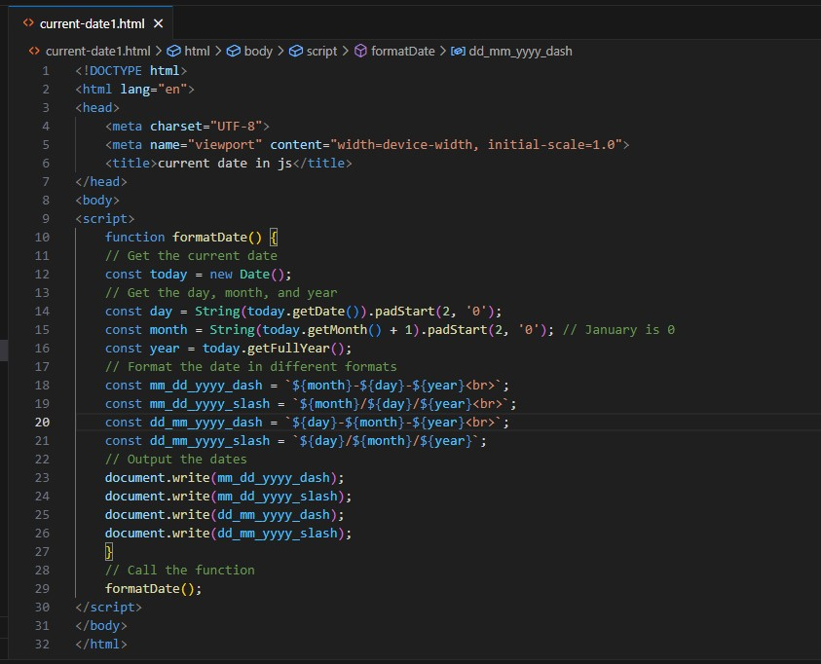

**Output:-**

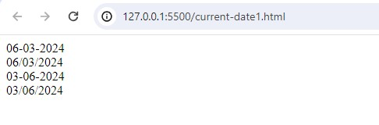

**Q.52 Use indexOf to determine the position of the first occurrence of a in 30 Days Of JavaScript?**

**A.52**

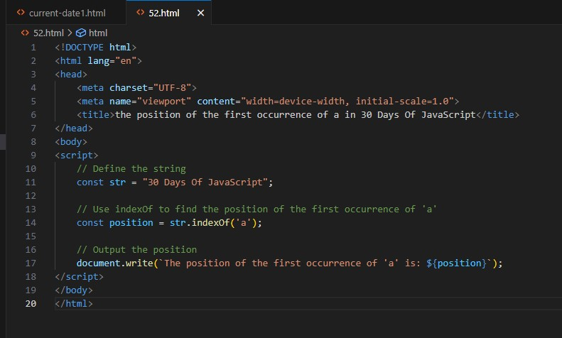

**Output:-**

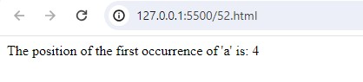

**Q.53 Use lastIndexOf to determine the position of the last occurrence of a in 30 Days Of JavaScript?**

**A.53**

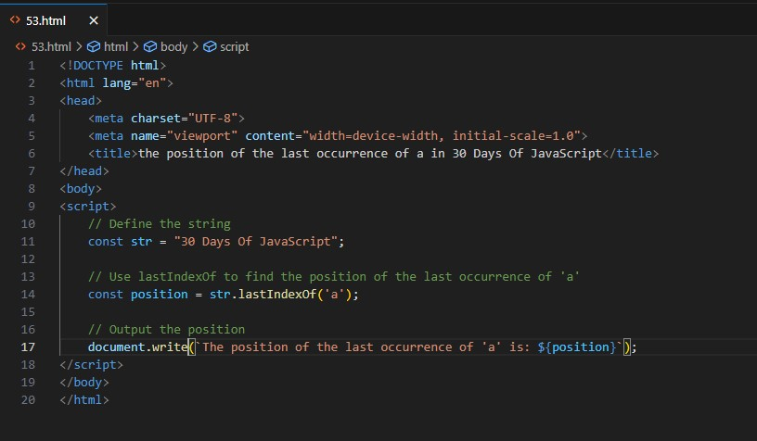

**Output:-**

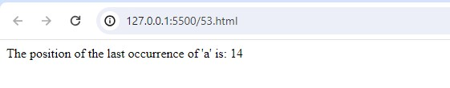

**Q.54 Form Validtion in JS?**

**A.54**

**Output:-**

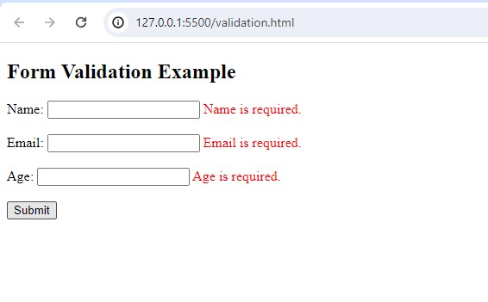

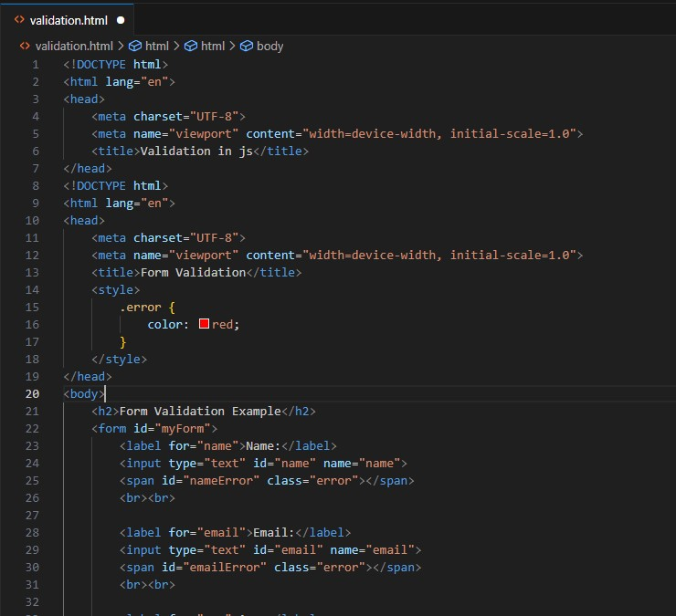

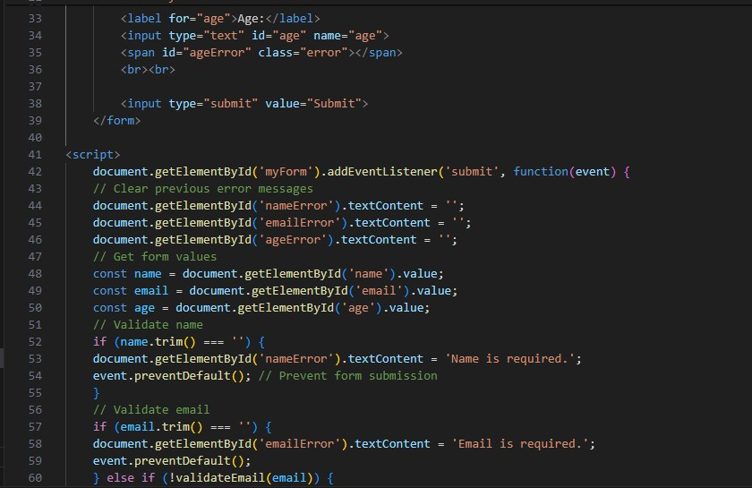

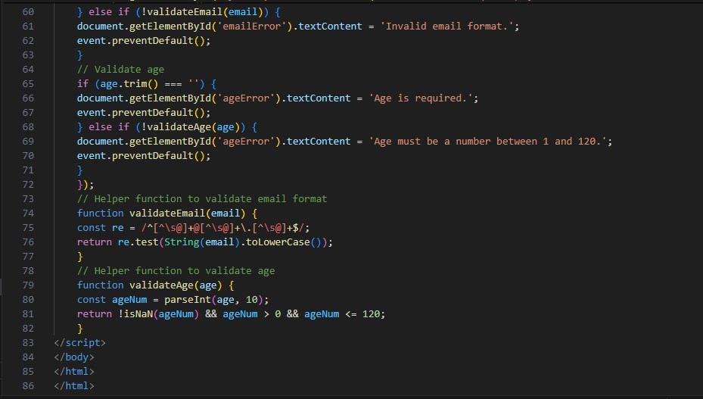

**Q.55 Form in Email, number, Password, Validation?**

**A.55 Output:-**

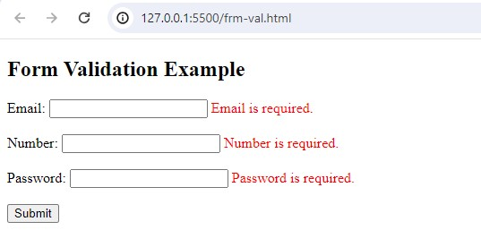

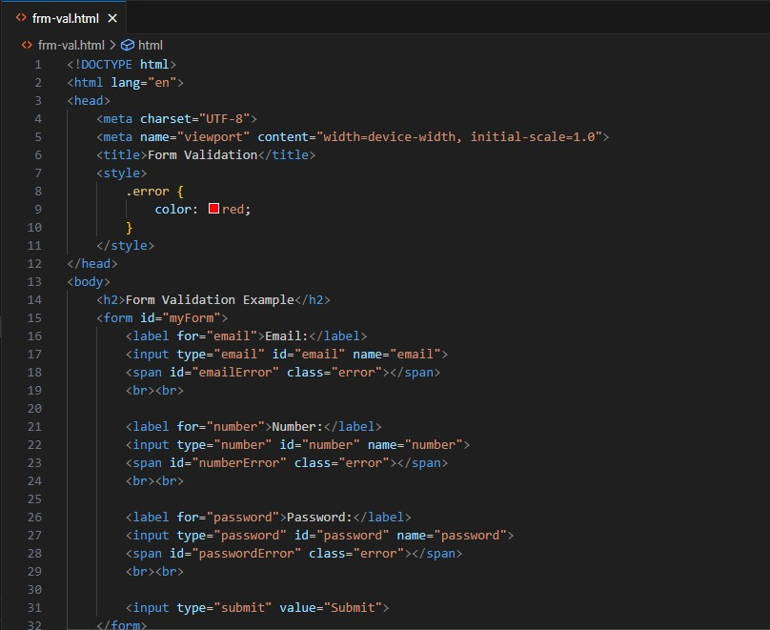

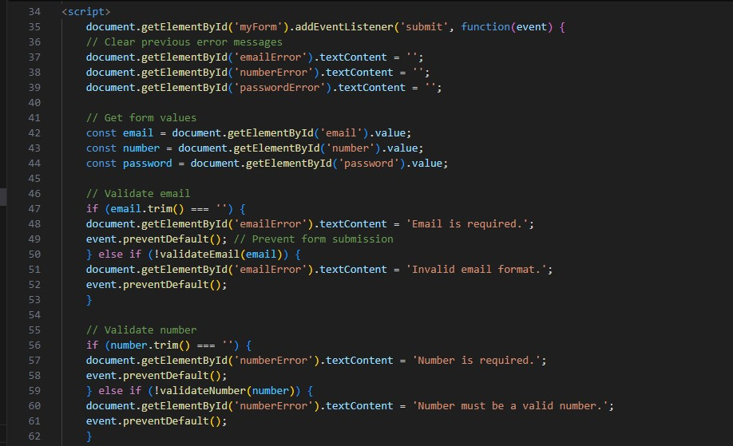

**Q.56 Dynamic Form Validation in JS?**

**A.56** Dynamic form validation in JavaScript is about providing real-time feedback to users as they interact with form fields.

This makes forms more user-friendly and helps prevent submission of invalid data.

**Q.57 how many type of JS Event? How to use it ?**

**A.57** 1.onchange = An HTML element has been changed

<button onchange ="document.getElementById('demo').innerHTML = Date()">The time is?</button>

2.onclick = The user clicks an HTML element

<button onclick="document.getElementById('demo').innerHTML = Date()">The time is?</button>

3.onmouseover = The user moves the mouse over an HTML element

<button onmouseover ="document.getElementById('demo').innerHTML = Date()">The time is?</button>

4.onmouseout=The user moves the mouse away from an HTML element

<button onmouseout ="document.getElementById('demo').innerHTML = Date()">The time is?</button>

5.onkeydown = The user pushes a keyboard key

<button onkeydown ="document.getElementById('demo').innerHTML = Date()">The time is?</button>

6.onload = The browser has finished loading the page

<button onload ="document.getElementById('demo').innerHTML = Date()">The time is?</button>

**Q.60 What is Bom vs Dom in JS?**

**A.60** Browser Object Model (BOM) is a browser-specific convention referring to all the objects exposed by the web browser.

The BOM allows JavaScript to “interact with” the browser.

The window object represents a browser window and all its corresponding features.

A window object is created automatically by the browser itself.

Java Script’s window.screen object contains information about the user’s screen.

It can also be written without the window prefix.

Document Object Model (DOM) is a programming interface for HTML and XML documents, that allows to create, manipulate, or delete the element from the document.

It defines the logical structure of documents and the way a document is accessed and manipulated.

With the help of DOM, the webpage can be represented in a structured hierarchy,

i.e., we can easily access and manipulate tags, IDs, classes, Attributes, or Elements of HTML using commands or methods provided by the Document object, that will guide the programmers and users to understand the document in an easier manner.

**Q.61 Array vs object defences in JS?**

**A.61** Arrays

Arrays are ordered collections of values, which can be accessed by their index

They are created using square brackets [] or the Array constructor.

Syntax:

let arr = [1, 2, 3, 4];

let arr2 = new Array(1, 2, 3, 4);

Each element in an array has a numerical index starting from 0.

Arrays have a length property that dynamically updates as elements are added or removed.

Objects

Objects are collections of key-value pairs, where keys (also called properties) are strings or symbols, and values can be of any data type.

They are created using curly braces {} or the Object constructor.

Syntax:

let obj = { name: "Alice", age: 25 };

let obj2 = new Object();

obj2.name = "Alice";

obj2.age = 25;

Each value is accessed using a unique key.

Properties can be added, modified, or deleted at runtime.

**Q.62 Split the string into an array using split() Method?**

**A.62** The split() method splits (divides) a string into two or more substrings depending on a splitter (or divider). The splitter can be a single character, another string, or a regular expression.

There are some methods to split the string into an array using split() method:-

Split using a space character

## Split a String by Each Character

## Split a String into One Array

## Split a String Using a Non-matching Character

# Split with a Limit

# Split Using Regex

# Replace Characters in a String using Split() Method

**Q.63 Check if the string contains a word Script using includes() method?**

**A.63**

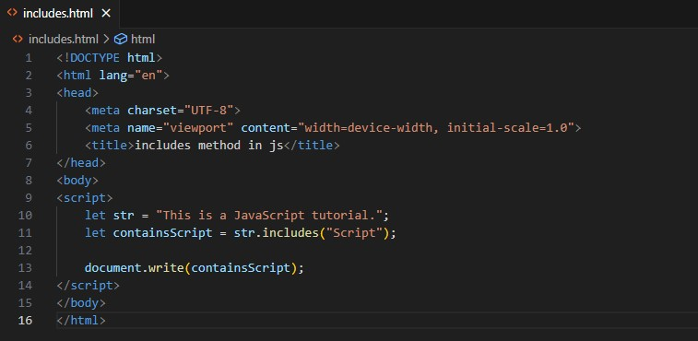

**Output:-**

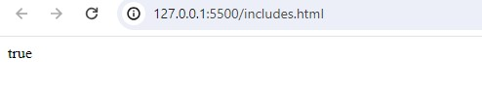

**Q.64 Change all the string characters to lowercase letters using toLowerCase() Method.**

**A.64**

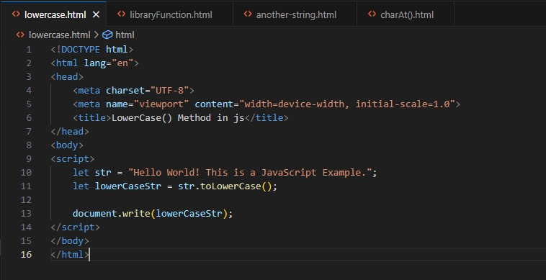

**Output:-**

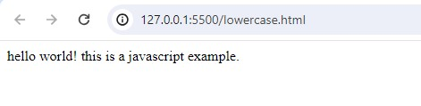

**Q.65 What is Character at index 15 in ’30 Days of JavaScript’ string? Use charAt() method.**

**A.65**

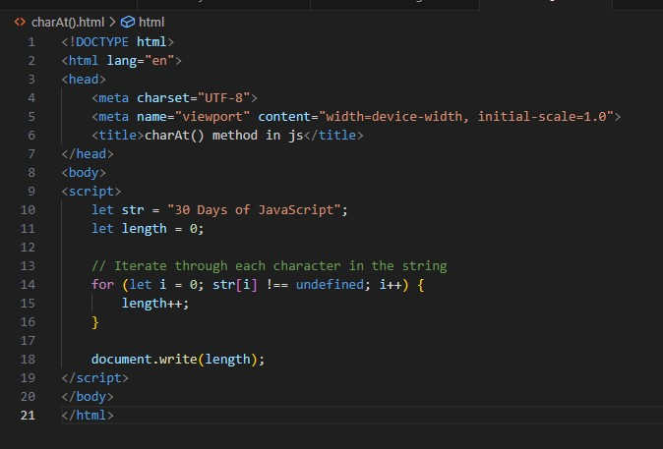

**Output:-**

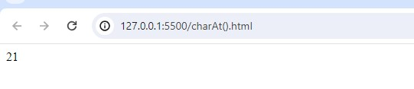

**Q.66 copy to one string to another string in JS?**

**A.66**

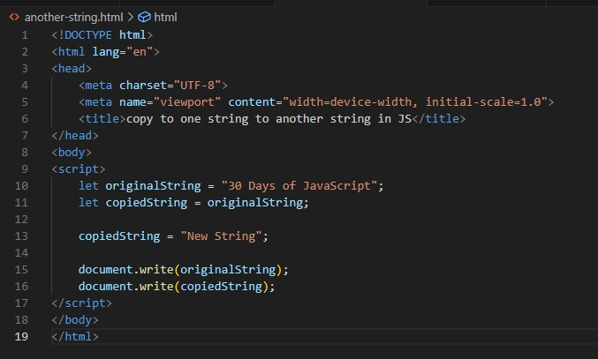

**Output:-**

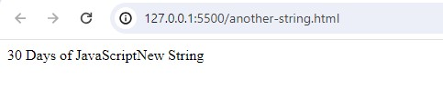

**• Create basic math operation in JS**

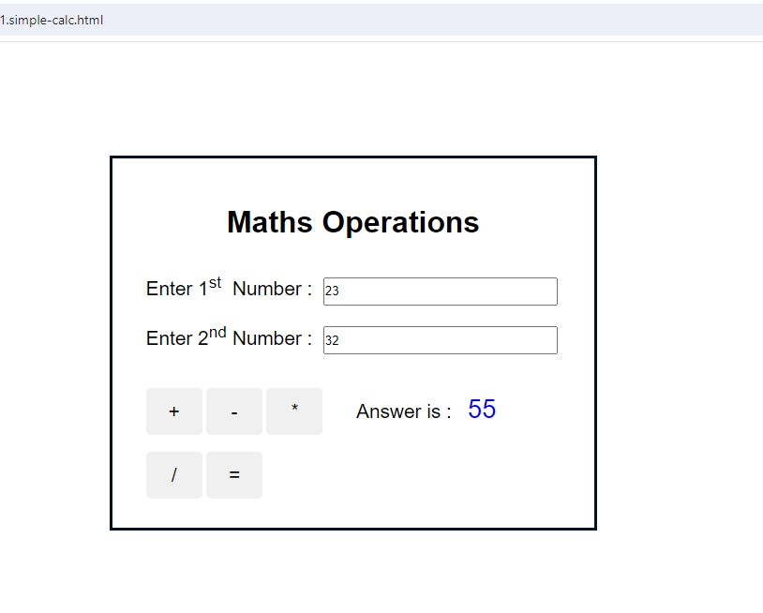

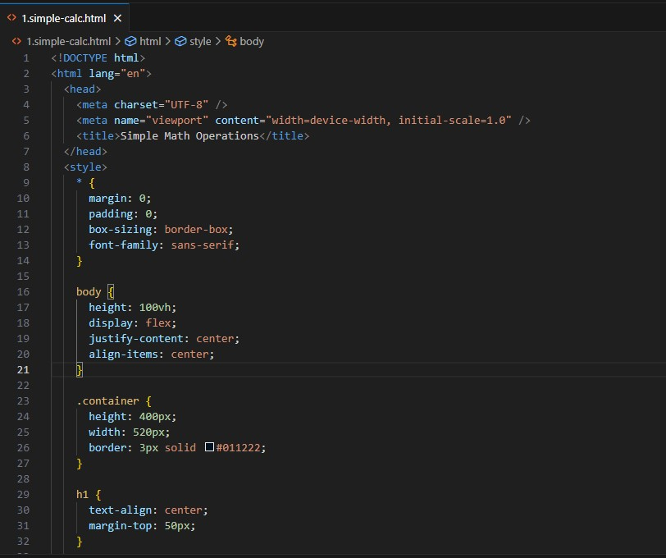

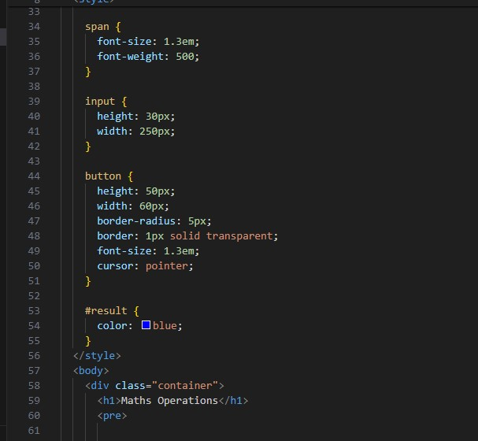

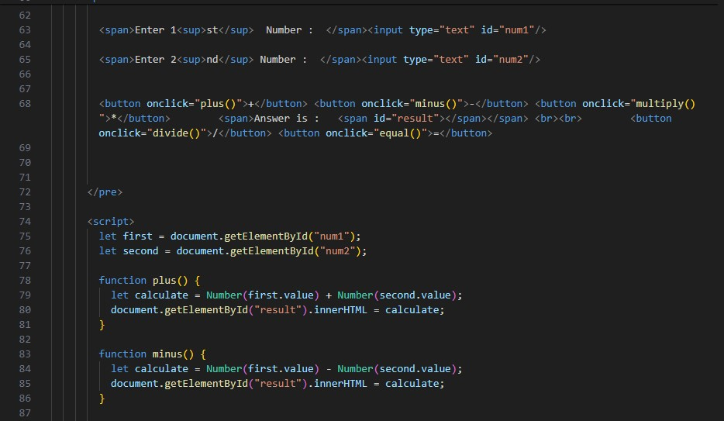

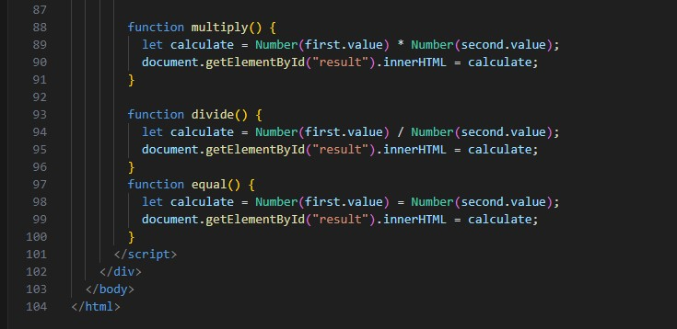

**• Create result**

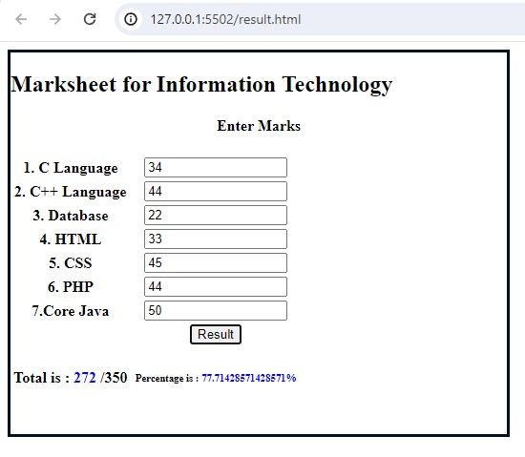

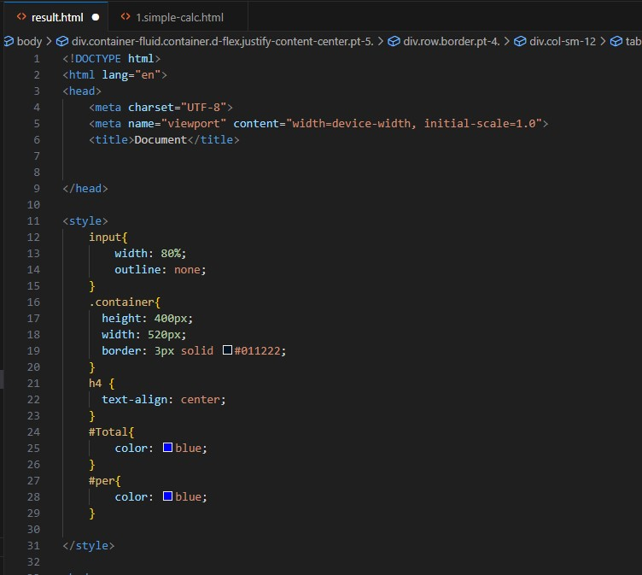

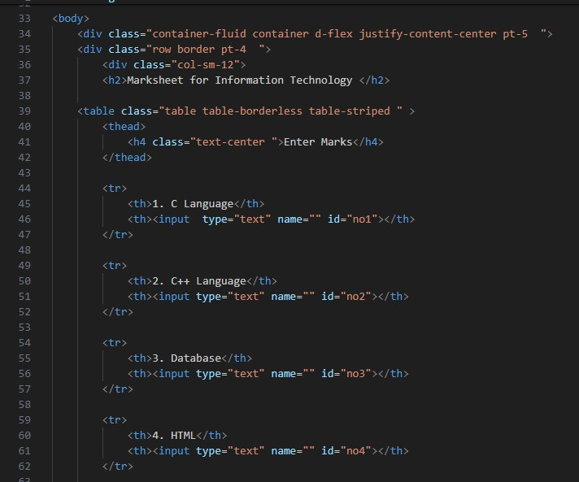

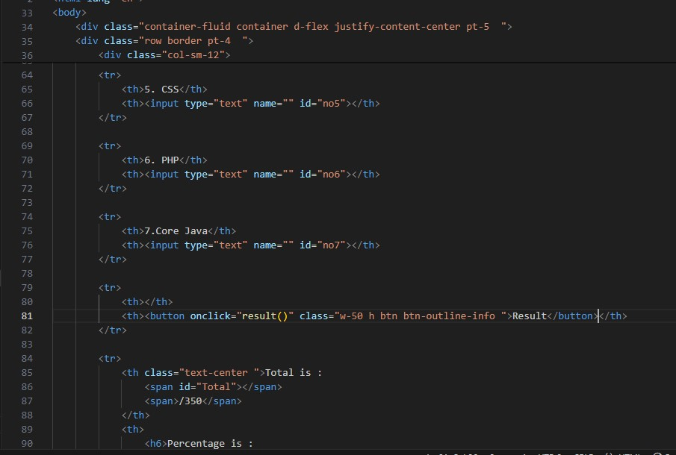

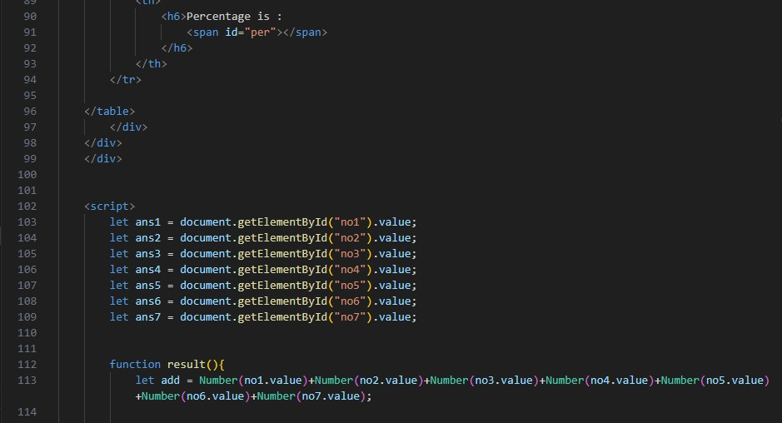

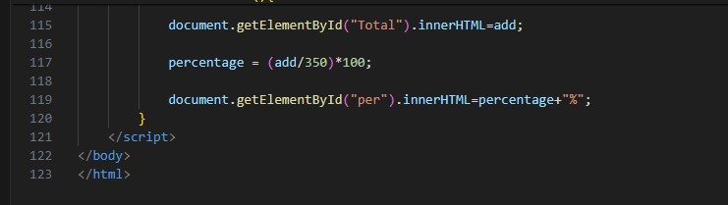

**• Create a slider using JavaScript**

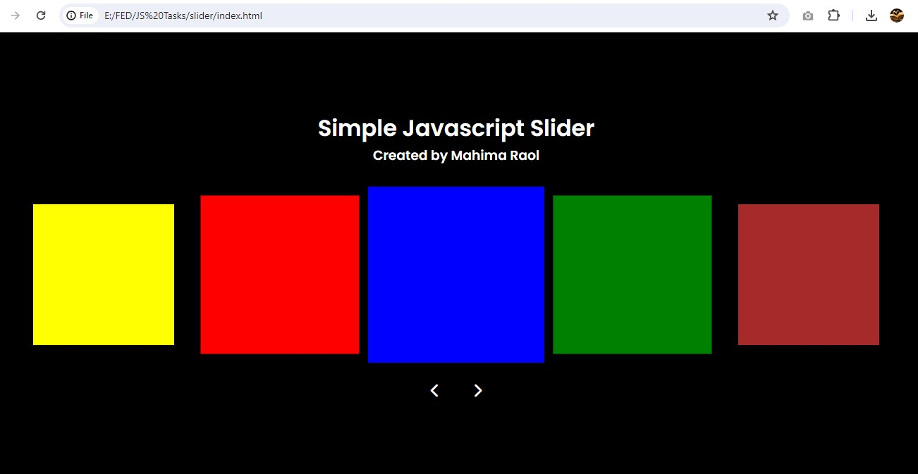

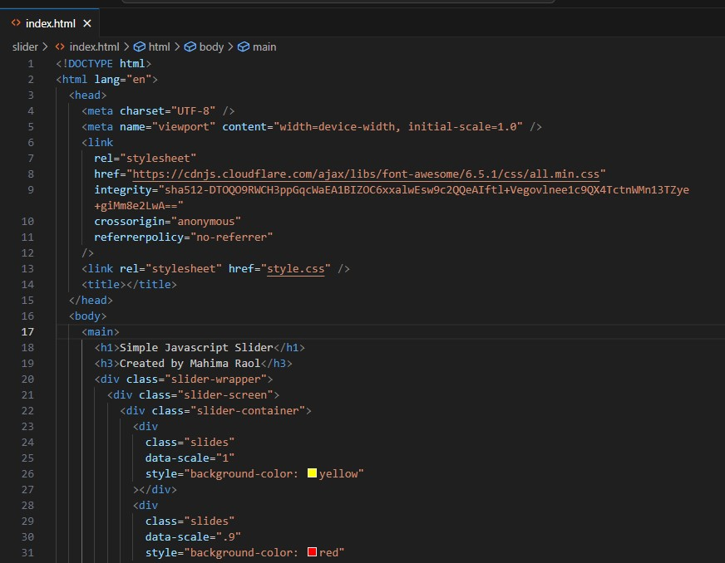

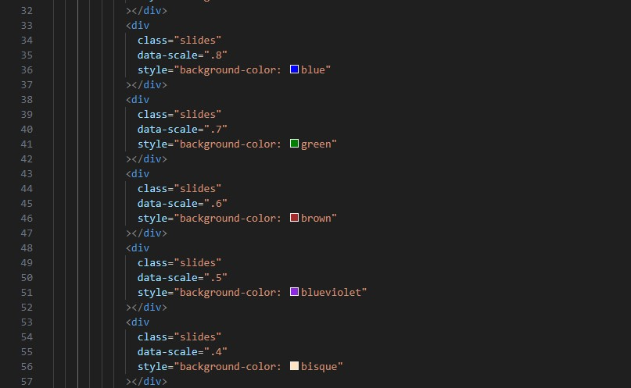

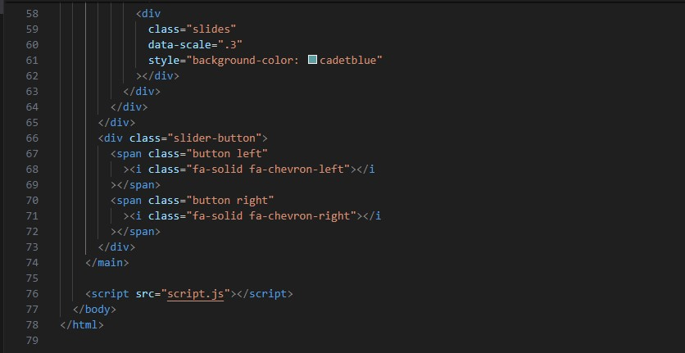

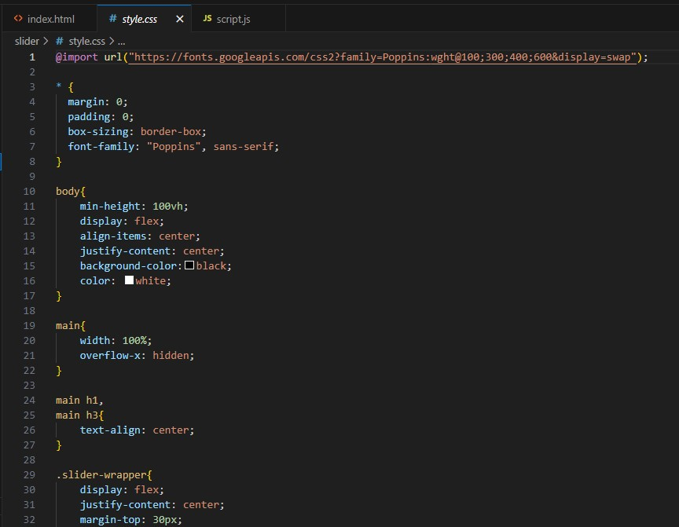

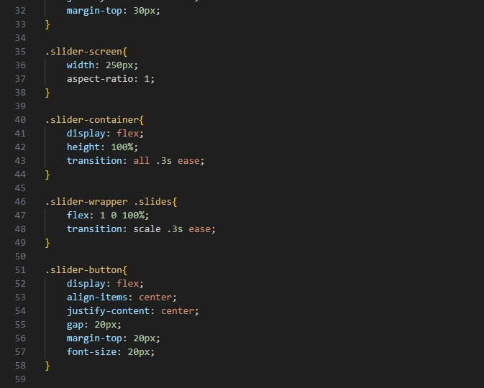

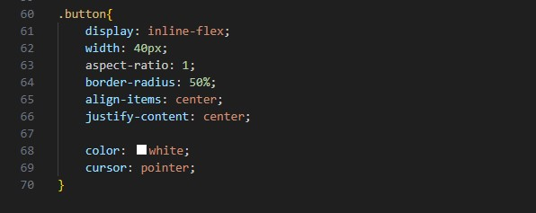

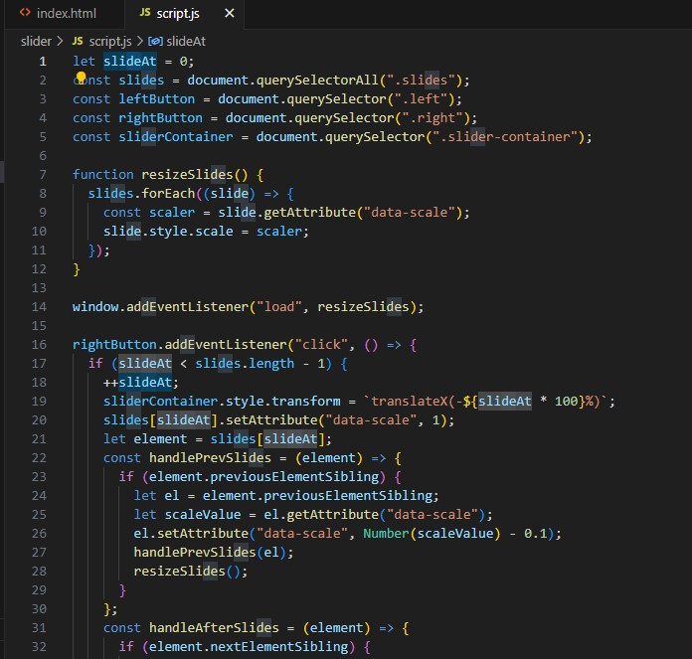

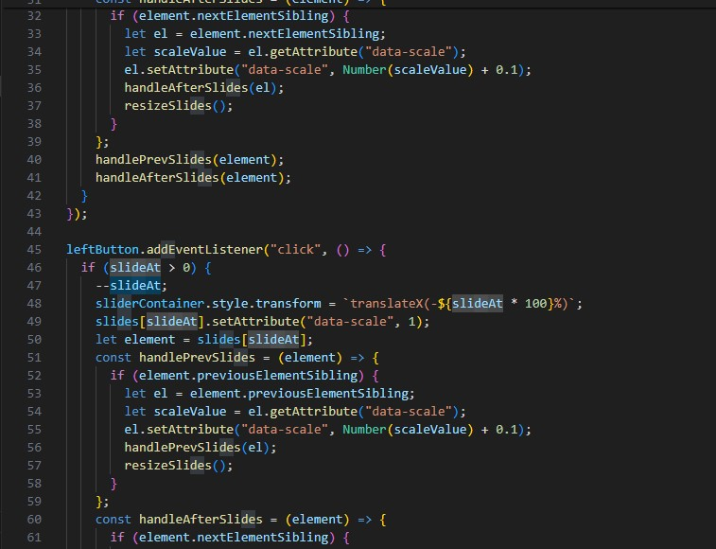

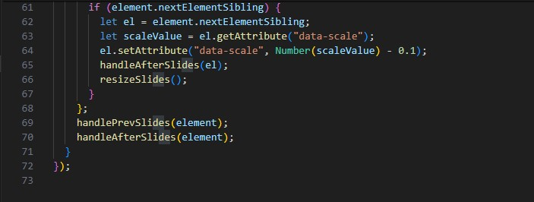

**● Change background using java script**

**ANS.**

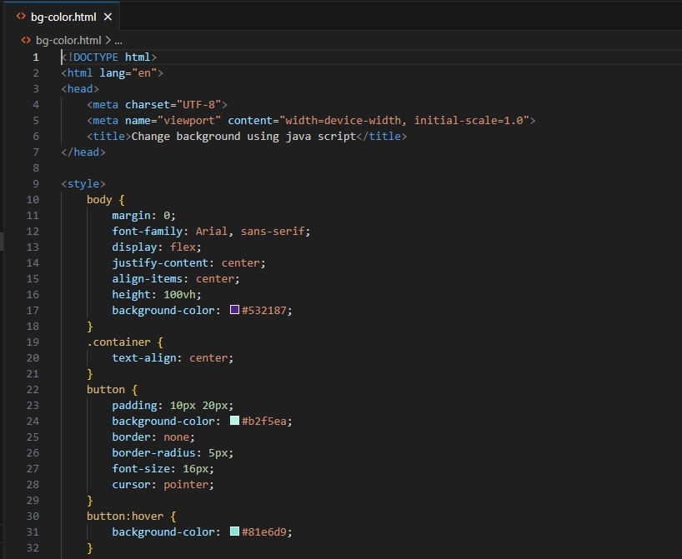

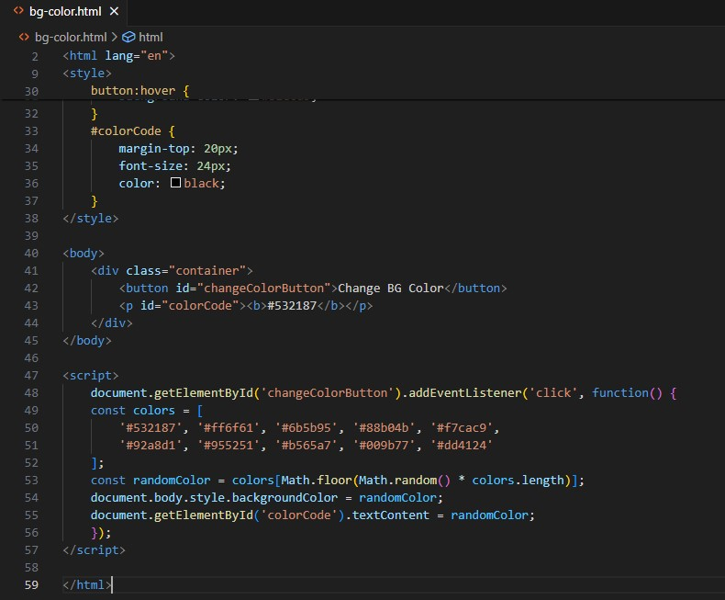

**Output:-**

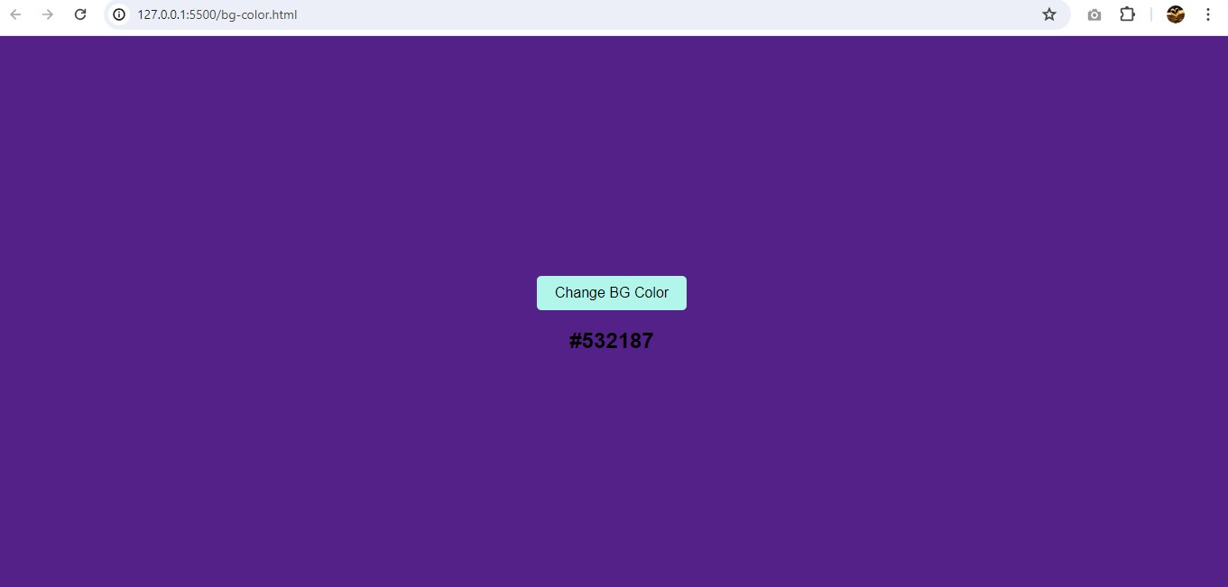

**• Create password field with show hide functionalities**

**ANS. Output:-**

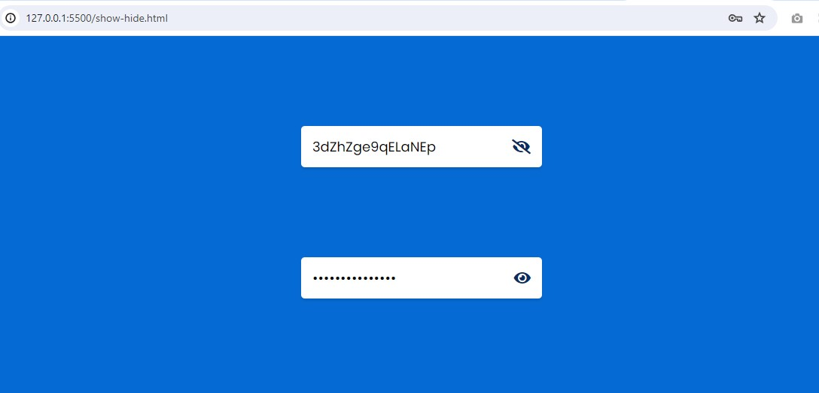

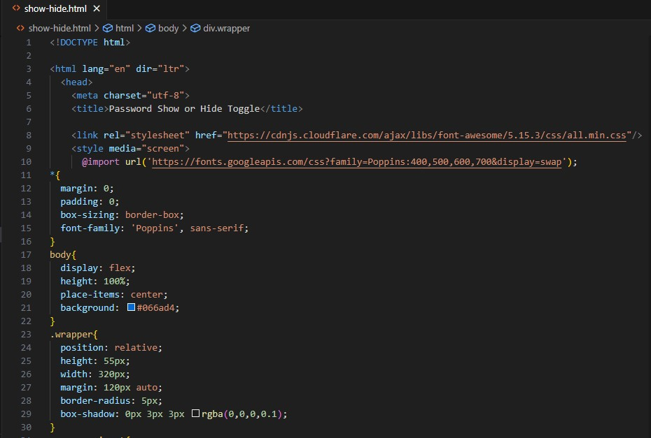

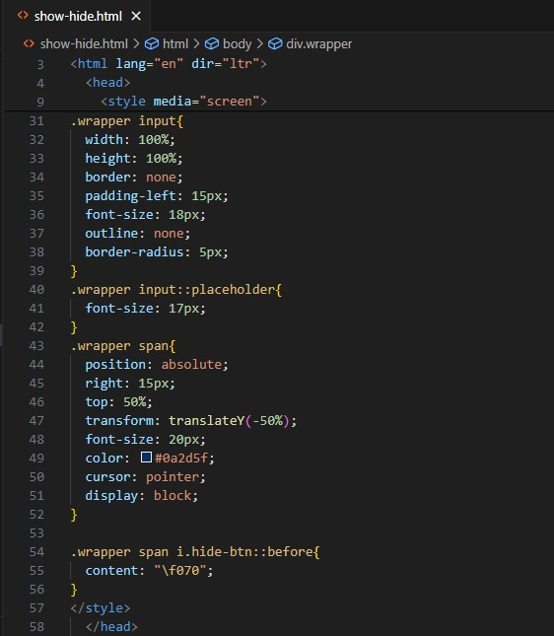

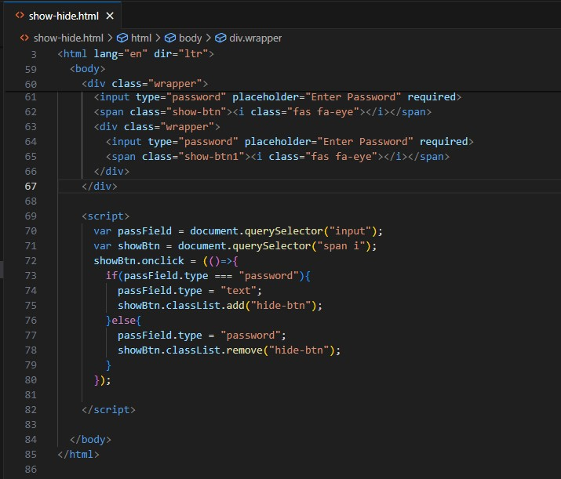

**● Create a form and apply validations as shown in below example.**

**ANS. Output:-**

